（the software for only win vista,win2k）
PX-888A SOFTWARE USER’S MANUAL
一、Open PX-888A software，you will see that as follow,
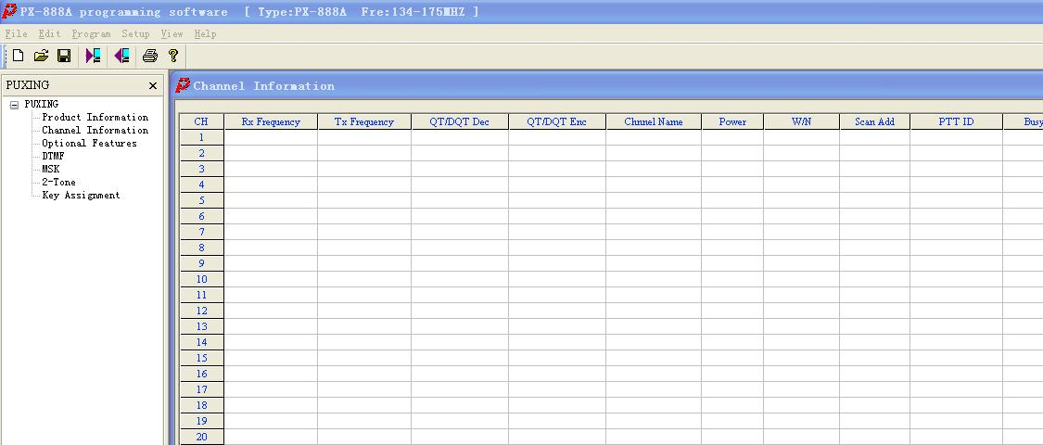
Picture 1
Click Edit/PRODUCT IMFORMATION，you will see that as picture， you can select PX-888A from TYPE，then select the frequency you want：136– 174MHZ、350 – 390MHZ、400 – 470MHZ。Click to confirm。
OK
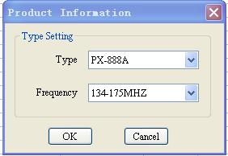
二、Programe the channel information（CHANNEL INFORMATION）
1）RX/TX FREQUENCY: input frequencies of transmitting or receiving, the frequency step are 2.5KHZ(LOW)、5KHZ(MIDDLE)、6.25KHZ(HIGH)。
2）QT/DQT DEC、QT/DQT ENC: QT/DQT(CTCSS/DCS) DECODE AND ENCODE
3）CHANEL NAME: To edit the alphanumeric channel name。
4）POWER, HIGH POWER and LOW POWER。
5）W/N, WIDE BAND(25khz) AND NARROW BAND(12.5khz)
6）SCAN ADD, YOU CAN SET TO BE YES OR NO。
7）PTT ID ,there are four types to send the ANI CODE
①OFF：no ANI code sent.
②EOT：send at the end of the transmit
③BOT ：send at the beginning of the transmit
④BOTH：both to send in the beginning and in the end
8）BUSY LOCK：NO、CARRIER ONLY and QT/DQT TONE.
Note: When select QT/DQT as busy lock, radio can transmit if carrier and tone are same separately, radio cannot transmit if carrier is same but the tone is different.
9）OPT SIGNAL：DTMF、MSK、2 – TONE。
10）MORE, add something for OPT SIGNAL。
三、OPTIONAL FEATURES
Click OPTIONAL FEATURES，you will see OPTIONAL FEATURES dialog box as follow,
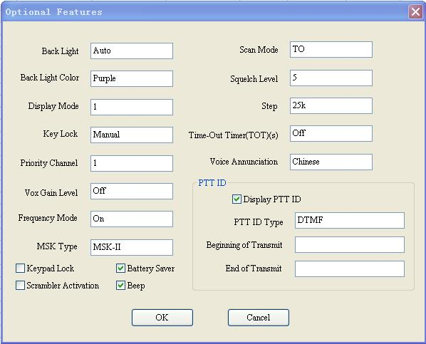
图2
- BACK LIGHT
  - OFF：BACK LIGHT is closed whenever you are operating or not。
  - AUTO：BACK LIGHT is on the state of AUTO. It will be ON when operating and OFF after stopping operating in 30 seconds.
  - ON：BACK LIGHT is on the state of ON all the time。
2）BACK LIGHT COLOR.
There are three types to select：PURPLE,ORANGE and BLUE.
3）DISPLAY MODE
There are five types of CHANNEL MODE.
☆CHANNEL MODE
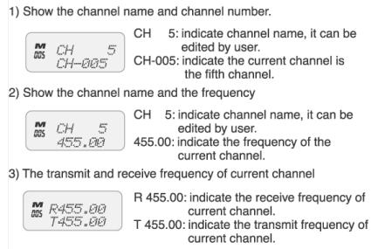
- FREQUENCY MODE
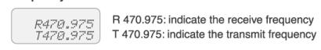
You can press VFO/MR to switch between Channel Mode and Frequency Mode.
Hold down ENTER and turn on the power, the radio can enter or exit the double channel mode.
5) Double Channel Mode
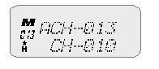
A CH – 013：this channel can receive and also send.
CH – 010：This channel can receive only.
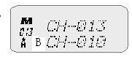
CH – 013：this channel can receive only.
B CH – 010：this channel can receive and also send.
You can press MENU+PTT to switch between A and B.
4）KEY LOCK
MANUAL：User can lock or unlock the buttons by the keypad。
AUTO：The keypad will lock by itself if you have no operation in 30 seconds，you should hold on the ”*”key to unlock the keypad.
5）PRIORITY CHANNEL
You can select one channel from 1 to 128 channels，if you select the fifth channel to be priority channel，it will scan the fifth channel always then other channels, for example:5-2，5-3, 5-4, 5-5, 5-6…….
6）VOX GAIN LEVEL
You can set the VOX GAIN LEVEL from 0 to 9 rank。
7）FREQUENCY MODE：ON/OFF
When the frequency mode is off，the radio will only show the Channel Mode，not show the frequency mode.
8）KEYPAD LOCK
If you select this function ，only PTT、SIDE KEY and channel selector are available. All other keys are disabled. (you can also long press and hold “*”and “#”)The difference between KEY LOCK and KEYPAD LOCK is that you can’t enable pressing the buttons by keypad ，you have to use the software to do that.
9）BATTERY SAVER：it means you open this function if you select it .
10）SCRAMBLER ACTIVATION：It means you open the scrambler function if you select it.
11）BEEP：The keypad will sound alert tone if you select this。
12）SCAN MODE
①TO（Time-operated scan）：The radio will lock on a busy channel for a period of 5 seconds then continue scanning other channels.
②CO（Carrier-operated scan）：The radio will stop scanning when receive a signal then keep on the same frequency until there is no activity.
③SE（search scan）：the radio stops on a busy channel and exits the scan mode.
13）SQUELCH LEVEL：0-9 adjustable
14）SETP：5K/6.25K/10K/12.5K/25K
15）TIME-OUT TIME
The range of TX limited time is OFF-270S.If you select the 30S，The radio will stop transmitting after 30 seconds transmitting。
16）VOICE ANNUNCIATION：OFF、CHINESE、ENGLISH.
17）PTT ID
①DISPLAY PTT ID：It will display the PTT ID on radio’s screen when transmit if you select this。
②PTT ID TYPE：DTMF、MSK
③BEGINNING TRANSMIT（ set the PTT ID at the beginning of transmit）
④END TRANSMIT （set the PTT ID at the end of transmit）
四、DTMT
Click DTMF，you will see DTMF dialog box，
- ENCODE，as follow,
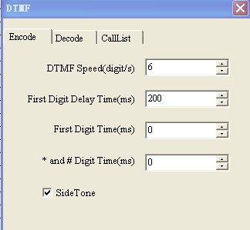
图3.1
DTMF SPEED：transmit speed
FIRST DIGIT DELAY TIME
FIRST DIGIT TIME
* AND # DIGIT TIME(MS):
2）DECODE as follow,
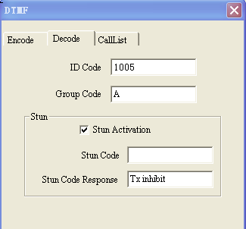
图3.2
ID CODE： RADIO’S ID, the ANI CODE WHEN YOU USE THE DTMF .
GROUP CODE:
STUN ACTIVATION：The radio hasn’t been killed if you select this.
The radio has been killed if you didn’t select this.
STUN CODE:
STUN CODE RESPONSE:
Two types：TX INHIBIT,TRANSCEIVER INHIBIT(BOTH TX & RX INHIBIT).
3）CALLLIST
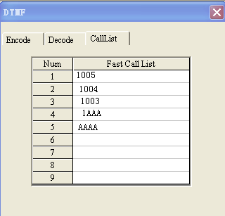
图3.3
五、MSK
Click MSK，you will see the picture as follow
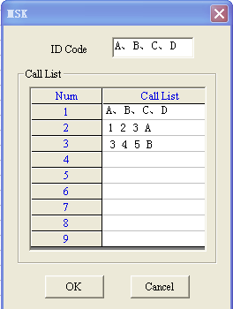
图4
each radio get only one ID CODE.
六、2-TONE
Click 2-TONE，you will see TONE dialog box，click ENCODE，you will see the picture 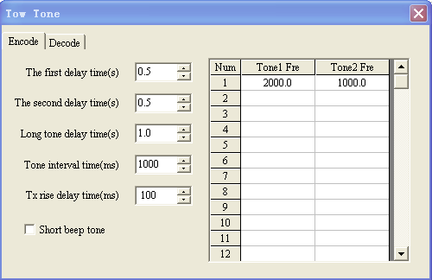
图5.1
THE FIRST DELAY TIME
THE SECOND DELAY TIME
LONG TONE DELAY TIME
TONE INTERVAL TIME
TX RISE DELAY TIME
SHOUT BEEP TONE
Click DECODE，you will see that as picture as follow,
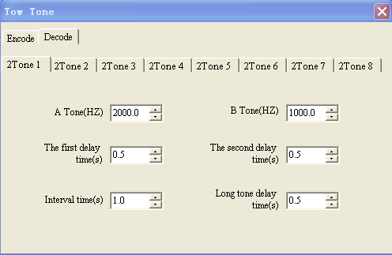
图5.2
Pleas note the first delay time, the second delay time and interval time should be same separately on Encode and Decode.
examples
Two pieces of two way radios was programmed as follow,
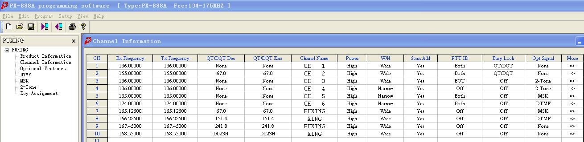
图6
一、Channel Information
The two pcs two way radio can communicate when both the frequency and the Opt Signal are the same.
2） BUSY CHANNEL LOCKOUT
☆When we select the CARRIER ONLY,if the first radio is calling the second radio on channel 1,the second radio only can receive but not transmit on this channel.
☆when select QT/DQT TONE
①If the value of the two radio (QT/DQT DEC and QT/DQT ENC)are the same，the first radio are transmiting on channel 2,and The second radio not only receive but also transmit on this channel.。
②If only one of the value (QT/DQT DEC and QT/DQT ENC) is different，then when the first radio is transmiting on Channel 2,the second radio can only receive but not transmit on this channel.
3）Power
☆switch the synthesis test instructment to TX SET,when we select the low power we will see 0-2（W）from the instructment.When we select the high power we will see above 4 w from the instructemnt.You can change the power as follow,
①high power :click the menu bar [PROGRAM] then HIGH POWER DEBUG,you will see ,
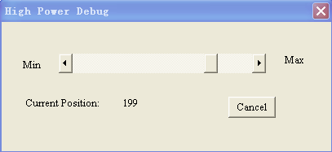
图7
You can adjust the high power from 1 to 250 by the scroll bar,you also can see PWH199 from the LCD of the radio.
②low power :click the menu bar [PROGRAM] then LOW POWER DEBUG,you will see ,
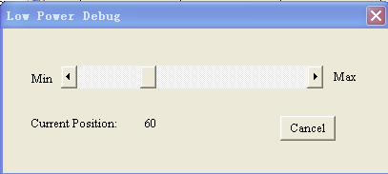
图8
You can adjust the high power from 1 to 200 by the scroll bar,you also can see PWH60 from the LCD of the radio.
3)PTT ID （We can press PTT key to send PTT ID directly，it will sound“dadada du”）
☆OFF：no send
☆EOT：send at the end of the transmiting
☆BOT ：send at the beginning of the transmiting
☆BOTH：both send at the beginning and the end of the transmiting
Click the menu bar [EDIT] then OPTIONAL FEATURES,you will see
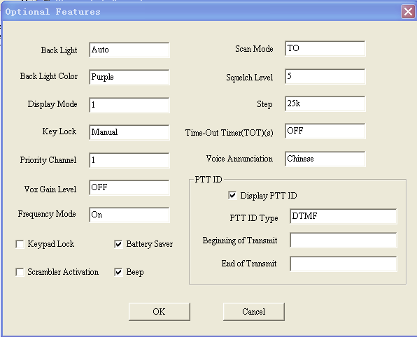
图9
We can use the PTT ID frame on picture 9 to set how to display the PTTID ,same as press“MENU+0”the LCD display“ANI ？”，then press ENTER to set if show the ANI or not

二、TONE（TONE FUNCTION SAME AS SQUELCH FUNCTION）
在呼叫信令后的30S内若没有进行发射则就会自动退出信令呼叫，并发出“咚咙“的声音，如果还要进行信令呼叫必须重呼。
The radio will exit the tone call by itself and soud “dong long”if you didn’t press PTT to transmit during 30 seconds after sending tone to call.
A、B、C correspond to the key：
MENU A ENTER B VFO/MR C
☆2-TONE：Select the channel got two tone（Channel4），press the side key 2 to make the two tone call 。It will sound if receive the correct 2 –tone.
●2-TONE set
Click the MENU [EDIT]/TWO TONE，then click ENCODE to jump picture10，click DECODE to jump picture11.
图10 图11
You can enter the frequency from 300HZ to 3 KHZ in TONE1 FRE and TONE2 FRE on picture10,the time you set to the Encode should correspond to the time set to the Decode.

- MSK：Select the channel got the MSK（Channel5），press key side 2 to use the FSK call。It will sound if receive the correct 2 –tone
- We can use the MSK tone to get the function of selective call.
Click channel5/MORE to jump picture12，click [EDIT]/MSK to jump picture13， Suppose we have two radio which got the tone information as follow
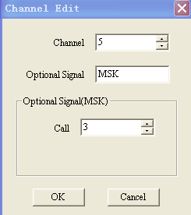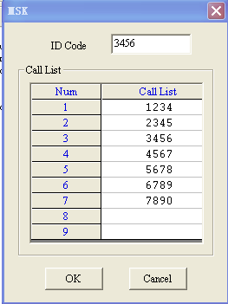
图12 图13
picture12, the CALL 3 in the dialog box corresponde to the NUM3 on picture13，we can call only when receive the CALL LIST 3 sent by another radio. So we can set the content on picture 12 and picture 13 to get the function of selective call.
- DTMF：
  - Operate：①Select the channel got DTMF（Channel6），press key side 2 until display“CALL ？”on LCD,then press the shortcut key to call DTMF code
②Press ENTER key to display“DTMF IN ---”，enter the ID CODE ，then press PTT key。
●We can get the function of single call, multi-call, group call by DTMF.点击Click [EDIT]/DTMF，then click DECODE to jump picture14，click CALLIST to jump picture15
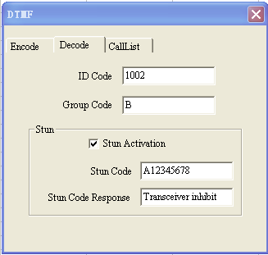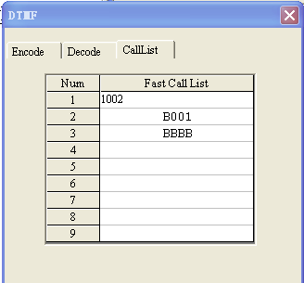
图14 图15
- Single Call：Suppose NO.1 radio to call NO.2 radio，this channel got DTMF，press side key 2，it will display“CALL ？”on LCD，then press shortcut key which have set to be the code of other body’s，you can call NO.2 radio。NO.2 radio will sound at that time，then NO.2 radio will send response code to NO.1 radio.
- group call：picture14，ID CODE is
1002
GROUP CODE is
B
And group code is 1BBB，so if only the first code is 1 in group B will ring. Group Call：as picture 14,ID CODE is
1002
GROUP CODE is
B
Group Code is BBBB，no matter what is the ID CODE，if only GROUP CODE is B,it will respond。
- Stun Activation
c
图16
- Operate：A.Press PTT key to enter the STUN CODE of another radio，the radio will be stunned activation once received the correct stun code;B.press”ENTER”key to enter the stun code of another radio then press PTTkey, the radio will be stunned activation once received the correct stun code.一、TX inhibit；二、Transceiver inhibit，TX inhibit，the radio been stunned activation can not transmit.Transceiver inhibit,the radio been stunned activaton can not transmit and receive.
- Side Key（Click Menu [Edit] to set）
  - Option Signaling Call
  - Emergency Call
  - Send 1750HZ signal
  - Squelch Off Momentary
Note：SIDE KEY not only got one function of above but also got the function as follow：1）Press MENU+SIDE KEY 2 to enter FM Radio Receiver；2）Hold on MENU+SIDE KEY 2,open the power to open the Self-Programming mode；3）SIDE KEY 2 stand for “D”. When we use the tone call ,we should set the side key to be Option signaling Call first.

