VHF Yagi antenna

6 Elements
FIG.1 shows a 6 elements VHF Yagi "homebrew" antenna designed
with YAGIMAX 3 and made by SV1XY and me with excellent results
on local and satellites contacts. (UO-14, AO-27 etc.)
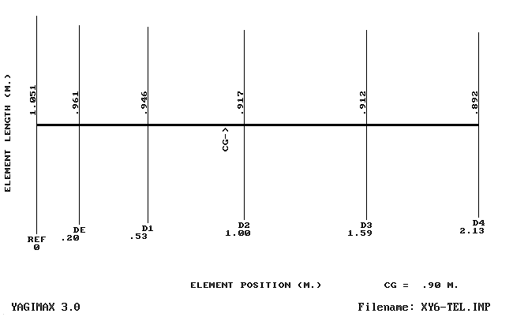
FIG.1
FIG.2 shows a graph for the SWR, GAIN and F/B ratio.
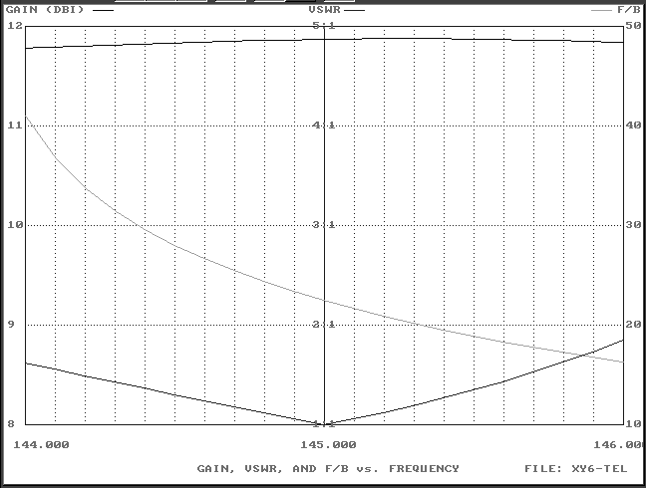
FIG. 2
The maximum forward GAIN is almost 11.9 DBi (abt 9.8 DBd) into 2 m. Band.
With almost 10 DBd gain, we have an Effective Radiation Power 10 times greater of the tranceiver maximum output (without Coaxial-Loss), i.e if you have an output Power of 50 Watts, your ERP will be multiplied 10 times = 500 Watts ! (in the forward GAIN direction)
I think not bad for a 6 Elements small-antenna (2.13 m. Boom) !
FIG.3 below shows a table about Gain, F/B, impedance & SWR
between 144 - 146 MHZ ( 2 m. Band)
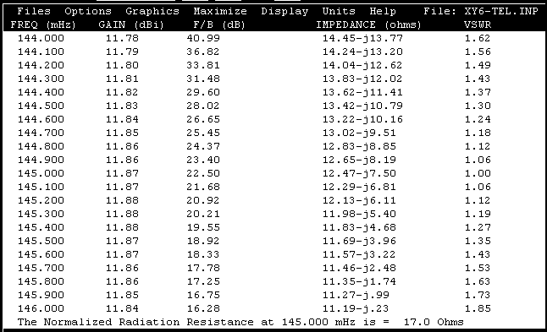
FIG. 3
The Radiation Resistance on center frequancy (145,000 MHZ) its 17 Ohms. In practice the antenna needs a "matching system" for a 50 Ohms coaxial cable feeder ( H-100, RG-213 or similar).
I have used a "Hairpin" system (FIG. 4), because is very simple and effective. YAGIMAX antenna design program has a calculation-tool for the Hairpin's dimension, depending on from "data" of the table above (FIG.3)
The Drive Element is an "Open - Dipole" (two pieces of about "Lamda/4")
with overall length 0.961 m. (see FIG.1)
FIG.4 shows the Drive-element (Dipole) and the Hairpin construction on the dipole's plastic box. The space between the two screws is 2.2 cm (dimension B) and the dimension "A" is 4.5 cm for 1:1 SWR (on my antenna).
If you have not the optimum SWR (1:1) you can increase or decrease the "A" dimension a few millimeters, looking for the minimum SWR.
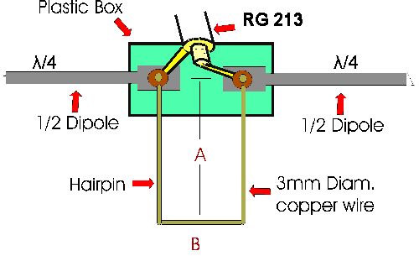
FIG. 4
The antenna has been constructed on a 15 x 15 mm aluminium boom and I have used for the elements aluminium tubular rods of 8 mm diameter. The plastic box wich I have used for the dipole it was from an old TV-antenna.
Keep in mind: this antenna has a sharp SWR curve in order to be achieve the highest gain. You must be careful with elements dimensions ! The maximum acceptable variation is ± 2% !
Finally, the FIG. 5,6 shows the polar-plots of antenna
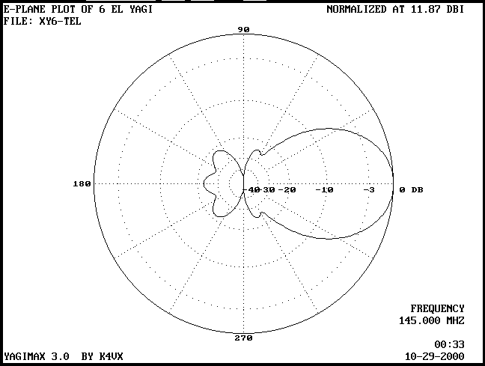
FIG.5
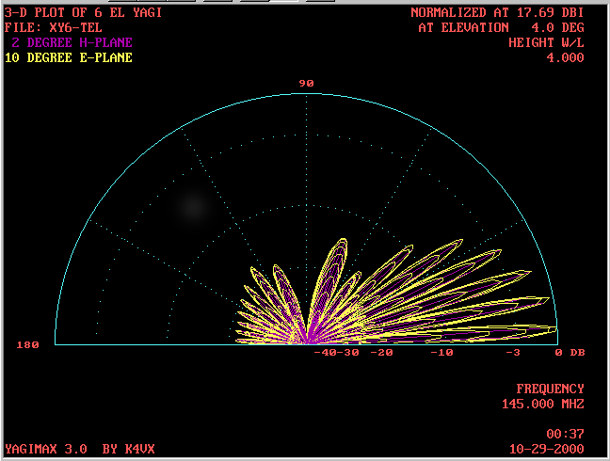
FIG.6
Good luck !
Costas SV1XY - Makis SV1BSX
Back to the HOMEBREW page

