Two Meter Band VHF Dipole

With "Gamma" match system
This page is the first part of my VHF Collinear antenna project, wich gives a gain of about 5,1 DBi with 2 dipoles and 8,1 DBi with 4 dipoles (Omni directional). This gain its not something "exotic" if the antenna compares with a 2 x 5/8 or a 3 x 5/8 "Lamda" Commercial antenna, which it has about a similar gain. The difference is the simplicity about this contruction, the common materials which I've used and the easy "matching" system. It havn't any strange "phase stamp", "mystery" coil or "secret" trap... just two or four dipoles with "Gamma match" system, few meters of RG cables and about 2 Kg... aluminium! I beleive that: this antenna its a temptation for any "homebrewer"!
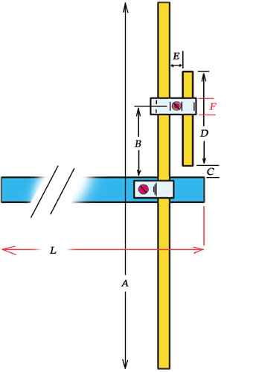 | Dimensions of Dipole  A = 99 cm  B = see text  C = 24 mm  D = 26,5 cm  E = 14 mm  F = 12 mm  L = > 50 cm
FIG. 1
Fig. 1 shows the dipole with full details. The BOOM of antenna its a piece of square aluminium 15x15 mm. The Length of Boom ( "L" dimension on Fig.1) it must be at least 50 cm (Lamda/4), otherwise the antenna will be lost the "Omni-directional" beaming, because in this case the metallic tissue or tower behind of dipole acts as reflector. This effect it can be canceled, if the distance between dipole and tower its "lamda/4" or more.

Dipole and Gamma-match, they are both from the same material, like Alumunium tube (pipe) with an external diameter of about 8mm.
The "Slide" bracket it has being constructed from an aluminium stripe, about 12 mm wide.

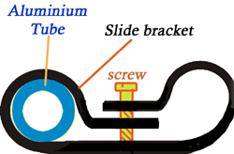
FIG. 2
Just by using a small vise or a pincers, you must be roll the aluminium strip over a drill - rod with slightly smaller diameter ( i.e. 7 mm) from the external diameter of dipole-tube.This way, we can make a simple "clamp" for the "Slide-bracket". (FIG. 2)
I've used the same material & method for the cetral-bracket on the dipole rod.
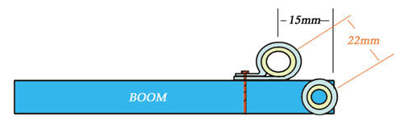
Figure above shows the dipole and "Gamma" rods ( Up view)
FIG. 3
The "Gamma match" is made by a piece of Aluminium tube with overall length of about 26,5 cm (dimension D ). The space between Dipole and "Gamma" rod its about 22 mm (FIG. 3). Gamma rod is parallel to Dipole rod.
The "matching system" is made by striping a part of RG58U cable, about 26 cm long. The most part of 26 cm must be insert into "Gamma" tube, just "insert" - do not connect anywhere. This way we make a capacitor... as you know, a capacitor has two plates... here the first "plate" its the internal (stripped) cable of RG58 and the second "plate" its the Gamma-tube. (Actually, its a cylindrical and not a planar capacitor).
Note: because the internal diameter of Gamma-tube is larger from internal cable of RG58, you must insert again into central cable of RG58 the outer piece (cover), without the shield. This way, the central cable will be keeping in the center-point along Gamma - tube. Picture below shows how you prepare the RG58 cable in four steps.
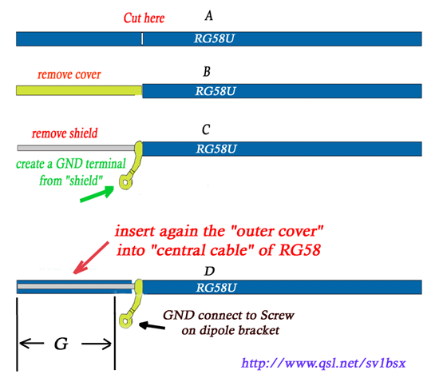
FIG. 4
"G" part on picture above, will be inserting into "Gamma-tube". The "shield" of RG cable must be connect to the screw on the dipole center-bracket. Figure 5 below shows the details.
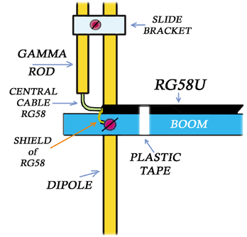
FIG. 5
Now, I suppose you have already the dipole with "Gamma-match". Cut the RG58 cable in order to be able an overall length between GND point (screw on dipole-bracket) and connector of about "Lamda"/4 x "odd" multipier x 0,66 (0,66 = velocity factor of RG58).
For example: Lamda/4 for 145 MHZ =0.517 meters...
0.517 x 3 = 1.551
1.551 x 0.66 = 1.0236 meters.
That means a total length from GND terminal on Dipole-bracket up to PL connector, about 1.024 m (Dimension "K" on FIG.6). Put the connector into a SWR meter and connect the other side of SWR with an handheld VHF tranceiver. Keep in mind, the rest part of transmition line between SWR and VHF TX (dimension " K' "), which includes the SWR, it must be also resonable for the desire frequency , like "K" part.
Now, set the output power to "Low" on VHF and the frquency to 145.000 MHZ . By installing the dipole about 2 meters above ground, press the PTT and adjust the antenna by sliding (moving) the "Slide-bracket" up or down, looking simultaneously for the minimum SWR on the SWR bridge.
In my prototype antenna, the distance between Boom and "Slide-bracket" was 24 cm for SWR 1:1 (dimension "B" on FIG.1). Finally, secure the screw with a screw-driver on the Slide-bracket and don't forget: all screws they must be from bronze-material.
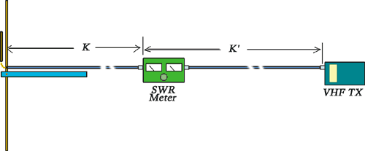
FIG. 6
Keep in mind: if you want just a simple dipole antenna (i.e for packet or APRS station), after the final installation in your tower the feed-cable it must be a good type of coaxial cable, like RG213, H100 or similar... I've used just a piece of RG58 ( close to Gamma-match) because is flexible and that helps to make the Gamma, but unfortunately the RG58 has a very "High Loss" into 145 MHZ ... so, just make the final piece close to dipole with that and the rest meters with something much better ! (RG213, H100 etc)
Finally, figure below shows the SWR curve between 142-148 MHZ. The dipole has an excellent SWR curve, absolutely symmetrical into 2 m Band.
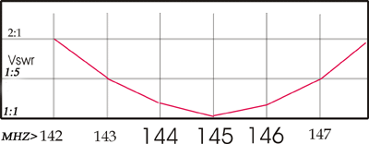
Table above shows the SWR curve v/s Frequency
FIG. 7

TA2HO, Hilmi OKUR
ESKISEHIR
e-mail: hokur@anadolu.edu.tr

