10 El. "Homebrew" UHF Yagi for AO-40 UpLink
For successful communication via "AO-40" by using the UHF UpLink, a Power of 150-200 Watts ERP is necessary.
Supposing that we have a transceiver with 15-25 Watts output, as the majority of All-mode UHF models, we need an Antenna-Gain of about 10 DBd in order to be able to achieve the recommended ERP.
The optimum for the AO-40 UpLink is Right Circular Polarization (RHCP), but is possible to trigger easily the "Bird", by using Linear polarity also.
On my research for a similar homebrew antenna drawing, I found very interesting the ON1DHT "UHF antenna-model", on his Web-page.
The design of my Homebrew 10 El. UHF Yagi is based on this, but in my page you will find many details of manufacture, which I could not find in any page, when I began to manufacture the aerial. On the other hand, you can find on my page additional infos, Polar plots, Gain tables etc, from "YagiMax" Antenna-design program.
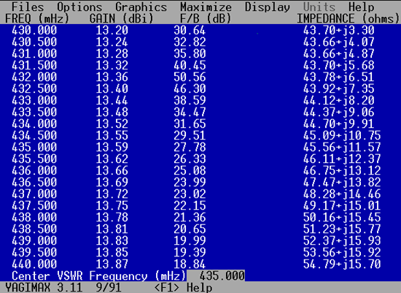
FIG.1
Fig1 shows a table about Forward Gain - F/B vs frequency.
The antenna has 13.59 DBiforward Gain (11.5 DBd) and it's pretty small, about 1,5 m.
Spec's of 10 El UHF Yagi
- Fwd Gain 13.59 DBi (11.5 DBd)
- 26 DB Front/Back
- 430-440 MHZ (SWR <1,5)
- SWR on 435 MHZ = 1:1
- Impedance: 50 Ohms
- Hor. angle: 33°
- Vert. angle: 38°
FIG.2. below shows the dimensions of Yagi antenna.
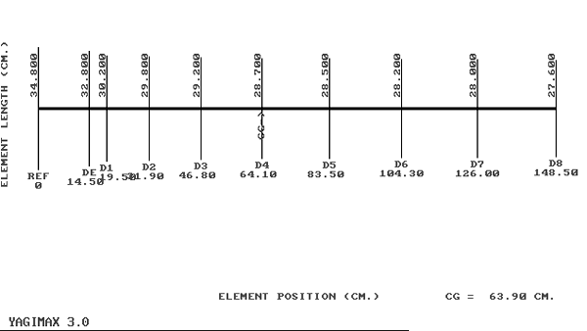
FIG.2
Keep in mind, the antenna has ideal relation between length & Gain... for 3-4 DBd more Gain we need in practice about double Boom (in length) and bigger number of Elements. So, it's very practical to keep the antenna small with high enough Gain, like the 11.5 DBd of 10 El. Yagi. On the other hand, a small antenna like this it's also a good choise for a portable system. The small length of antenna allows us to place it easily in the port-package of our cars together with a small Dish (ie. 60cm Offset).
Construction
The antenna is being constructed into a 15x15 mm square-tubular aluminium Boom. For the dipole (only) I've used 8 mm tubular alumin rod. All other Elements (including reflector) are made from 5 mm alumin rod.
It is very important for the antenna to maintain right diameters on Dipole and Elements. Also the distance (spacing) between the elements its critical. (See Table below)
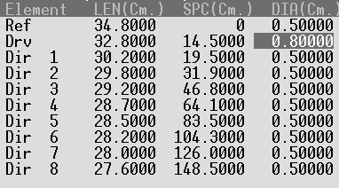
The antenna needs a "Bracket" for mounting into the Mast. The Bracket take place behind of reflector and Never - I repeat NEVER, between Elements! For this reason the Boom is few Cm bigger than 148.5 Cm.
If you want a center-point Bracket, the Mast should be not metallic, but is recommended a supporting-point behind of reflector (back-supporting).
The Dipole
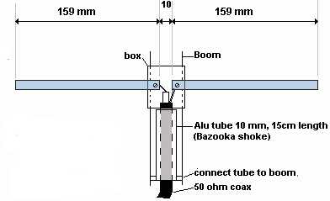
Fig.3
Fig.3 above shows the Dipole's details (ON1DHT drawing).
The Dipole should be isolated from the Boom, so it's necessary a plastic box. I' ve used a TV antenna Dipole's plastic Box, in order to support the Dipole and keeping that isolated from the Boom.
All the other Elements are connected into the Boom without isolation . I' ve used small aluminium-stripes in order to support the elements into the Boom. Additionally I have drilled each element in the center-point. I have passed a small screw (or rivet) through that hole for supporting and securing the position of each element into the boom (Figures below).
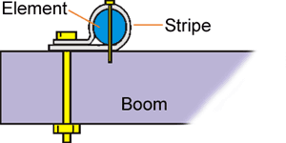
Fig.4
A second screw (or rivet) is passed through the stripe and Boom. Thus, the mechanical construction of antenna is pretty good.
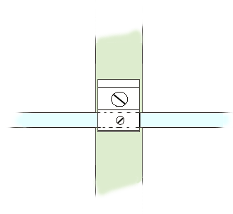
Fig.5
The Bazooka !
The Antenna uses a "Bazooka" tube on feeding- point between "Balance dipole" and "Unbalance" Coaxial cable. Keep in mind, the "Bazooka" tube is connected electrically with Boom on the side close to Reflector, by using a metal (aluminium) stripe.
Fig. 6 below shows another view of "Bazooka" construction.
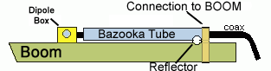
Fig.6
The "Bazooka Tube" is being constructed from Aluminium tubular rod 10mm (1 cm) diameter. The length of tube is 15 cm.
The coaxial cable passes through the Bazooka-tube and then connected into the Dipole.

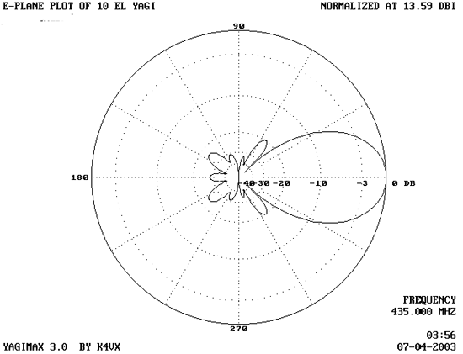
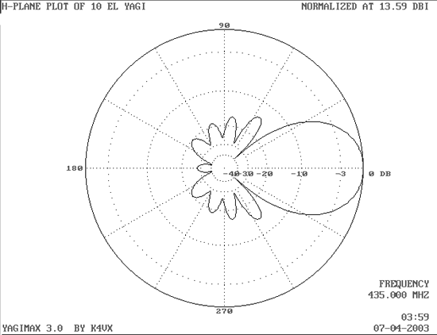
Figure 7
Figure 7above shows the E-plane & H-plane of 10 El. UHF Yagi antenna.
AO-40 UpLink
I'm using this antenna with Vertical polarity on both systems for AO-40, portable and fixed. For portable use, I've used a Kenwood TR-9500 UHF All-mode Mobile transceiver, with just 15-17 Watts Output (modified, it's only 10 W from Kenwood). The coaxial cable between TX and Antenna is not too long, about 1.35 m (3 Lamda x VF*), in order to be able to keep the losses, as low is possible. By using this "setup", I have achieved to make a lot of QSOs "via" AO-40, as Portable station. The Effective Radiation Power is about 150 Watts (15 W of TX-out x 11.5 DB Antenna Gain "minus" 1-1.5 DB of Coax & N-type connector).
*VF=Velocity Factor, 0.66 for RG58, RG213 etc.

On my fixed station I'm using the same Transceiver, but I've a long-long Coaxial cable (4-5 DB loss) from my Shack up to my UpLink Antenna. Thus, It was not possible to feed my 10 El. Yagi with high enough Power, to achieve the recommended ERP.
Solution: I'm using a small UHF-Linear Amplifier, behind of Antenna, very close to Dipole. This way, I can keep the Losses very "Low" between UHF - PA & Antenna, because now the Coaxial cable it's few Centimeters. The UHF-PA has a Gain of about 6-7 DB... so, if the input is supplied with 5 Watts, the UHF-PA giving an output at least 20 Watts x 11 DBd of Antenna-gain, I've an ERP Power over 200 Watts !
This antenna is not just for AO-40 Uplink. It's also an excellent antenna for any use in UHF Band, because it has "Low SWR" between 430 - 440 MHZ.
Finally, if you have any question, Email-me.

That's all folks - Have Fun
Makis SV1BSX (July 2003)
All rights reserved 2003-2004
For HAM-Radio PERSONAL USE ONLY

