GM4JMU

SHORTENED DIPOLE

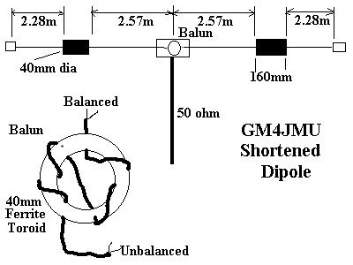 The GM4JMU Shortened 7Mhz Dipole
To construct each side of the antenna proceed as follows. Cut a 10.25 metre length of 24/0.076 insulated wire, and a 160 mm length of 40 mm o.d plastic tubing ( white plumbers tubing). Measure a 2.75 portion of the wire and attach the wire to the plastic former. Wind 40 turns of the wire onto the plastic former, and firmly secure the end of the winding. Make the other half of the antenna in the same way. Attach the ends of the 2.57 metre sections to a suitable centre insulator, which should also mount the choke balun, connect the 50 ohm coax, then carefully waterproof the whole assemby.
The choke balun uses RG174AU coax and a 40mm Ferrite Toriod.
Once the antenna is errected adjust it to resonance on 7.030Mhz by folding back the ends, and adjust the length to provide minimum SWR.
Article from SPRAT Issue 74 Spring 1993

A Shortened 7 mHz Dipole
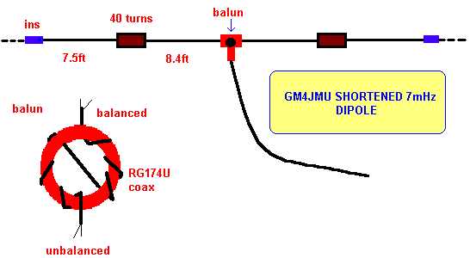

The shortened dipole for 7 mHz was described by Ken GM4JMU in Sprat 74.
It is made from insulated wire - Ken used 24/0076. The coils are wound on 40mm ferrite as above, with 40 turns of the same wire on 1.5 ins PVC tube and may be water proofed if required.
The balun at the centre is wound with miniature coax (RG174U). Tuning is best done in the clear and the preferred method of adjusting to resonance employed..

The same idea can be used to provide a mult-band doublet, by substituting tuned feeder for the coax.

The dipole described would be useful for the amateur with limited space and also for portable use.

Back to the first page

