W5DXP's No-Tuner, All-HF-Band,

Horizontal, Center-Fed Antenna

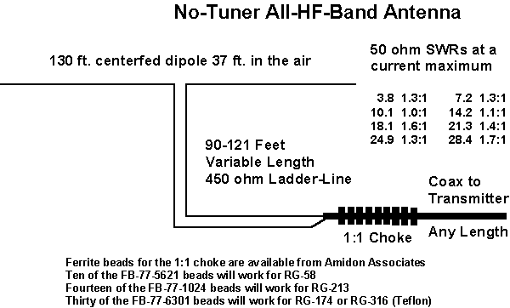

The No-Tuner, All-HF-Band, Horizontal, Center-Fed Antenna is our old friend, the 80 meter halfwave dipole dressed up a bit. By varying the length of the 450 ohm ladder-line feeding the antenna, we can achieve an SWR of less than 2:1 on all frequencies on all HF bands with the exception of the lowest part of 80m. On 75m, we are feeding the antenna with a half-wavelength of ladder-line. On 40m, we are feeding it with 3/4 wavelength of ladder-line.

No antenna pruning required. My transmission line really does tune my antenna system.

Special thanks to Walt Maxwell, W2DU and Jim Bromley, K7JEB.

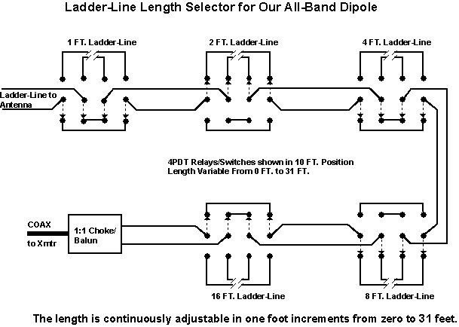

The Ladder-Line Length Selector actually does tune the antenna system so no conventional "antenna tuner" is needed - no coils and no capacitors. Switches or relays (remote control) can be used for the switching function and should be sized according to the RF power levels involved. W5DXP presently uses ten DPDT Knife switches attached to a piece of plexiglas mounted in the hamshack window. For portable or backpacking use, the length selector function can be performed simply by 1/2/4/8/16 foot pieces of ladder-line with mating connectors on the end. The proper length of ladder-line is selected to cause resonance in the antenna system.

Here's a table that explains it all. The transmission line always consists of a matching section and from zero to six halfwavelengths of ladder-line. The impedance at the antenna is shown along with the 450 ohm SWR and the impedance at the transmitter is shown along with the 50 ohm SWR, i.e. the SWR seen by the transmitter.
..Freq-MHz.. | ..T-line length = Matching Section + 1/2WL's.. | ..Impedance at XMTR.. | ..50 ohm SWR.. | ..Impedance at Antenna.. | ..450 ohm SWR..
3.8 | 109.5' = 109.5' + 0 | 69 ohms | 1.4:1 | 71+j84 | 6.6:1
7.2 | 92.0' = 30.5' + 1x61.5' | 40 ohms | 1.2:1 | 4939-j716 | 11.2:1
10.125 | 99.4' = 12.0' + 2x43.7' | 50 ohms | 1.0:1 | 116-j510 | 9.1:1
14.2 | 110.2" = 16.6' + 3x31.2' | 53 ohms | 1.1:1 | 2120+j1886 | 8.5:1
18.14 | 101.9' = 4.3' + 4x24.4' | 81 ohms | 1.6:1 | 111-j267 | 5.5:1
21.3 | 94.8' = 11.6' + 4x20.8' | 70 ohms | 1.4:1 | 1210+j1378 | 6.4:1
24.95 | 94.1' = 5.35' + 5x17.75' | 65 ohms | 1.3:1 | 186-j593 | 6.9:1
28.4 | 102.8' = 9.2' + 6x15.6' | 87 ohms | 1.7:1 | 721+j1009 | 5.2:1

75M Graphs | 40M Graphs | 30M Graphs | 20M Graphs | 17M Graphs | 15M Graphs | 12M Graphs | 10M Graphs

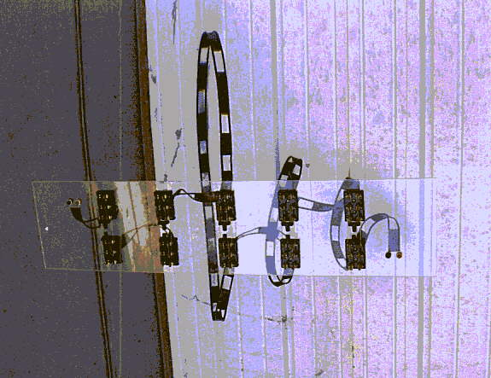

Here are the ten DPDT switches mounted on a piece of plexiglas that mounts in W5DXP's hamshack window. It shows the ten DPDT switches with the one foot, two feet, and four feet loops installed. The eight feet and 16 feet loops are not installed yet in this picture. RF flow is right to left from banana socket set to banana socket set. When installed in the hamshack window, the switches are on the inside and the loops of ladder-line are on the outside.

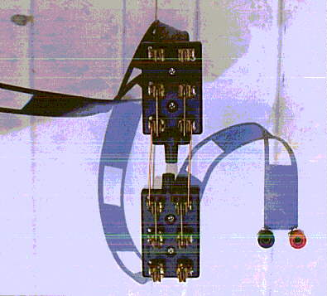

Here's a close up view of the one foot section. The RF flow is right to left into the banana sockets. The switches are shown in the shorted position, i.e. the one foot loop is floating completely out of the circuit to avoid capacitive effects. The bare copper wires in the center are the short. When the switches are thrown into the other position, the one foot loop is inserted into the circuit and the short is completely out of the circuit. This is the cleanest mechanical configuration W5DXP could think of but there might be a better way.

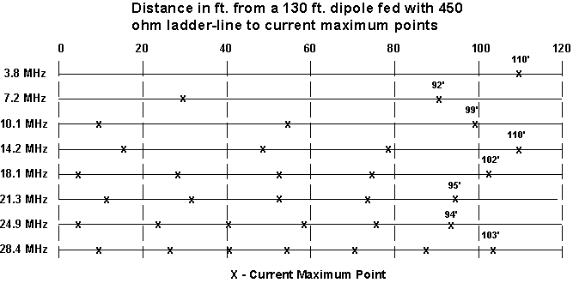

This is a plot of all the current maximum points between the antenna and W5DXP's shack. The transmission line is 90 feet long and the Ladder-Line Length Selector can add in an additional zero to 31 feet for a total of 90 feet to 121 feet. 90 feet matches the antenna on about 7.3 MHz and 121 feet matches the antenna on about 3.6 MHz. The matching points for all the other HF bands lie between these two extremes. Note that if a fixed length of ladder-line needs to be chosen for best results with this antenna, that length should be around 100 ft. which should work with internal autotuners. Caution: Do not expect a similar antenna erected in a different location to exactly match W5DXP's results. The antenna environment has a large effect on the antenna characteristics so W5DXP's results are only approximations when applied to other antenna locations and environments. Mounting this antenna in an inverted-V configuration, for instance, is likely to change the characteristics by an unexpected amount. "450" ohm ladder-line characteristic impedance varies all the way down to 375 ohms for the #14 stranded configuration and velocity factor varies among the different manufacturers and batches of ladder-line.

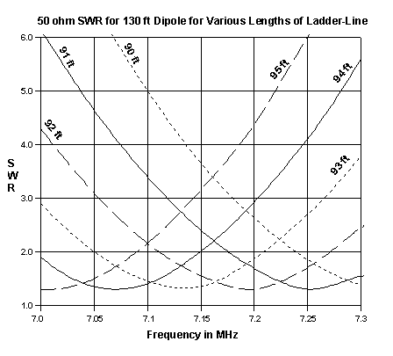

Who says a full-wave dipole is hard to match? Here's what EZNEC predicts will be the 50 ohm SWR across the 40 meter band for W5DXP's No-Tuner All-HF-Band Antenna given the chart lengths of ladder-line. Similar SWRs occur in similar patterns on the other HF bands.

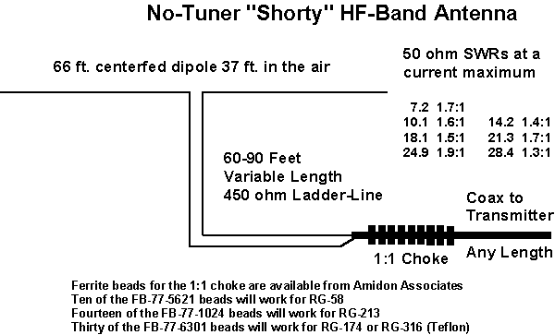

For those who don't have the space for a 130 foot antenna, here's a "Shorty" version designed to work on all HF ham frequencies above 7 MHz. Like the bigger version, the 50 ohm SWRs predicted by EZNEC are below 2:1 for the bands of interest. This antenna will work on 75 meters at reduced efficiency with a matching network or tuner.

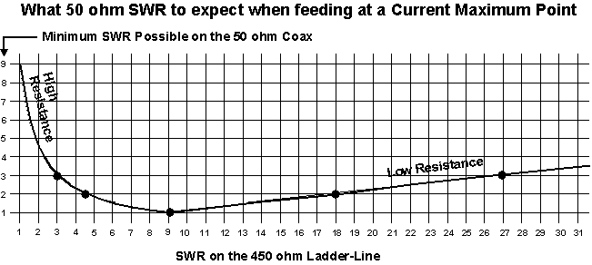

Here is the physics that makes it all possible. Any 450 ohm SWR between 4.5:1 and 18:1 will result in a 50 ohm SWR of less than 2:1 IF the antenna system is fed at a current maximum point. Moral: Make your center-fed HF antenna system at least a half- wavelength long at your lowest operating frequency and feed it at a current maximum point on the ladder-line.

Optimum Length For A Matching Section
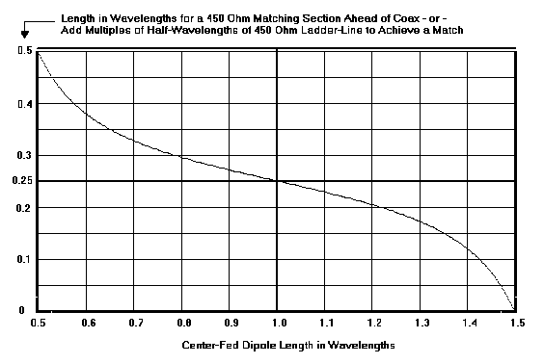

This graph shows the optimum length for a matching section when feeding a center-fed horizontal dipole. The bottom of the chart is normalized to wavelengths so it works for most HF frequencies and most popular lengths of center-fed wire dipoles. The left side of the chart indicates the optimum wavelength for a 450 ohm ladder-line matching section for connection to coax or connection to a multiple of half-wavelengths of 450 ohm ladder-line.

Example: Assume a 102 ft dipole on 7.2 MHz. 102/(936/7.2) equals 0.785 wavelengths on 7.2 MHz. Reading the matching section length from the graph yields 0.3 wavelength. A wavelength of 450 ohm ladder-line on 7.2 MHz is 886/7.2= 123 ft. 0.3 times 123 equals 36.9 ft for the 7.2 MHz matching section. Add 123/2 = 61.5 ft if 36.9 ft is too short for a total of 98.4 ft.

The following BASIC program approximates the optimum feedline lengths given the length of a horizontal dipole and the frequency. It works for both 300 ohm and 450 ohm ladder-line by assuming a velocity factor of 0.8 for the 300 ohm and 0.9 for the 450 ohm. The results are only approximations based on EZNEC and must be fine-tuned to perfection in reality. Cut and paste this program to Notepad and store it in the BASIC directory as Imax.bas

Note: This BASIC program only works for horizontal dipoles, not for inverted-V's or any other folded antenna.
10 REM This program calculates optimum ladder-line
20 REM lengths given dipole length and frequency
30 CLS
40 INPUT "Enter Frequency in MHz ", freq
50 INPUT "Enter Dipole Length in Feet ", diplenft
60 INPUT "Enter either 450 or 300 for Z0 ", Z0
70 IF Z0 = 450 THEN LLWL = 886
80 IF Z0 = 300 THEN LLWL = 787
90 dipwl = diplenft / (936 / freq)
100 IF dipwl < .5 THEN dipwl = dipwl + 1
110 IF dipwl < 1.5 THEN GOTO 140
120 IF dipwl > 1.5 THEN dipwl = dipwl - 1
130 GOTO 110
140 fedlinwl = .25 - (TAN(2.5 * (dipwl - 1))) / 12.02
150 fedlinft(0) = (LLWL / freq) * fedlinwl
160 FOR i = 1 TO 7
170 fedlinft(i) = fedlinft(0) + i * ((LLWL / 2) / freq)
180 NEXT i
190 PRINT "Imax points (Current Loops) at"
200 FOR i = 0 TO 7: PRINT fedlinft(i), : NEXT i
210 PRINT : PRINT : GOTO 40
220 END

