Try to make Hentena for 10m
Design : No (1) - (4) parts are shown in the picture below.
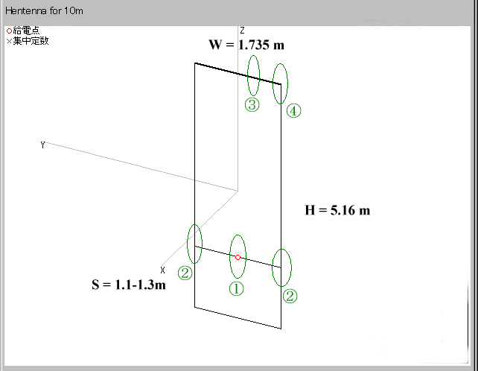
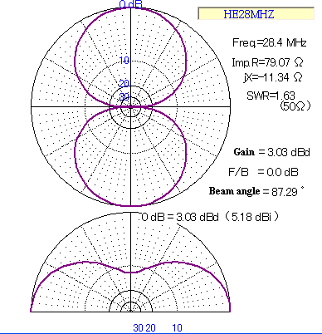

How to make it .. ( for your refference. ) Close-up pitures :
(1) Feeding point  (Need water protection! and this is sortterm use. It is beter to replace coax cable to more hevy-duty one. It is better to have a 1:1 balan to convert balanced-unbalanced conversion and it helps SWR issues)  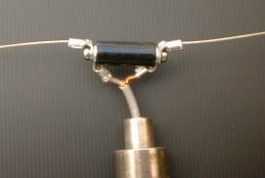 | (2) T-Junction (Sliding capability to adjust)  Using two Solder-less terminal with a set of 3mm bolt & nut (It's easy for "S" adjustment)  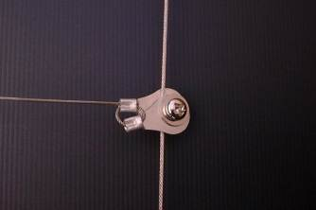
(3) Pipe-pipe connection  R-Pin (for field operation only)  For long term use, need to use stenless bolt instaed.  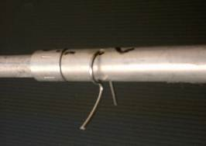 | (4) Pipe-Wire connection  Using self-tapping bolt  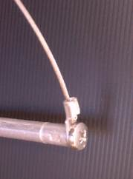
Back to Hentenna Top

