PACKING

CRATE ANTENNA

I have been placed in a situation where a landlord denied permission to erect an antenna. Any form of antenna was unreasonable, even a white-painted broom handle caused interference!! My dartboard frame did not cause any interference at all. This antenna was based upon a packing crate lid, as is often found wrapped around heavy machinery. Such packing crates are used by Ford, Volvo, and Ericsson. They all have a metal band around the frame of the lid. I found mine on the stairs of my place of work with "WET PAINT" scrawled across it. Most of the crates I have seen are made by a company called NEFAB here in Sweden; their biggest customer is Ericsson. You can often find these crates beside rubish skips or in basements.
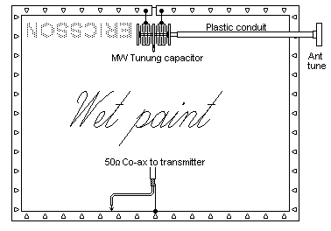
The larger the lid is the better the results. Paint it black and hang upon it a dartboard. Nobody will ever suspect that it is realy an antenna and is used for transmitting. The antenna is also quite portable & robust; It can be just thrown in the back of a car and hung on a tree, a lamp-post or any convenient support. I have used this antenna with up to 50 watts of RF power at HF, and it functions well from 7 MHz - 30 MHz without any form of switching, just a bit of tuning.
The first prototype antenna was about 1 meter wide by 0.75 meters. Cut a 1 cm notch out of one side and place a 270 + 270 pf MW tuning capacitor across the gap. The capacitor MUST be air-spaced, as was commonly found in the older MW transistor radio's. Do not be tempted to use modern plastic capacitors or you will have a wonderful pyrotechnic display on TX even with QRP. Larger packing crate lids are more efficient and operate at lower frequencies, but they give an increased impedance at the cut-out which will reduce the maximum power you can use with a simple receiver type tuning capacitor.
The tuning is fairly narrow, but hand-capacity can detune the antenna quite a bit, so you must extend the capacitor shaft with a length of plastic conduit so that it can be tuned, without getting your hands in contact with the metal forming the loop. Touching the loop will give you a bit of a burn if you use powers of more than 10 watts. Tune the antenna for minimum VSWR.
RF is coupled to the loop antenna by means of a tap as shown in above. I have used a coupling loop shaped something like a coathanger with the first few antennas, but the method shown is a little simpler. Adjust the RF tapping for best VSWR. I have worked several european countries with the antenna from Stockholm, on a 2nd floor balcony.
Finally, if you use a Futaba R/C servo to tune the antenna it may be situated well clear of the operator. The Futaba R/C servo requires a square-wave pulse of 1mS which is varied between 0.5mS and 1.5mS. This will give you 180 degrees of rotation. Cheap servo's seem to move in minute jerks in one direction, but are quite smooth in the oposite direction. The RED and BLACK wires are 6 volt power and the WHITE (or YELLOW) wire is for the 5-volt pulses. Radiating 50 W does not seem to affect even the cheapest of servos mounted at the antenna.
I hope that you have as much fun with this antenna as I have. It was always a great talking point when visitors saw it.

