
"Home of the RASCAL"
Antennas, Accessories, Connectors, and Components
My Favorite Multi-Band Antenna

The "WINDOM"
By G. E. "Buck" Rogers Sr; K4ABT
In September of 1949, I was tired of climbing poles and trees to move, remove, add, or change my single-band HF antenna's. In those younger years of my HAM radio career, I had used single band dipoles and doublets for almost every HF Amateur band. I had tried long-wires, doublets, dipoles, and Zepps, but again, operation was restricted to single band operation, maybe two bands at most.
I had heard of the "Windom" and read a few articles about the Windom, but most of my thoughts were ... ho-hum.. just another dipole fed a bit off-center. Then one evening at a meeting of the GARC in the old "Sea Scouts" club house near the Coosa River in Gadsden, Alabama; I heard some of my "elmers" Gale Caudle (then W4CFB), Jack Kennamer W4YPC, Bob Bynum W4USM, Vic W4CWF, Ed Elkins W4CDI, Homer Dupree W4OZK... and others discussing the Windom all-band HF antenna. It was when Jack mentioned using one (Windom) antenna, on most all HF bands that my ears went directional!
That last phrase caught my undivided attention. "most all HF bands, ....etc"
What ! A multi-band HF antenna ? Surely I had been blessed.
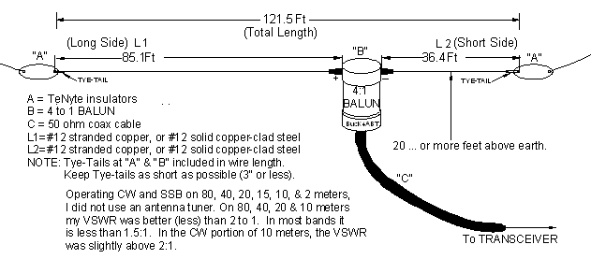
To think that I could put up a Windom, and no longer have to climb the poles and trees to hang another (single band) HF antenna was great news to me. To be able to use it without an antenna tuner was icing-on-the-cake. For a kid without extra funds, an antenna tuner was a luxury that I could not afford. Even my transmitter was a single 807 rig I homebrewed on an old Atwater-Kent radio chassis, my grand-father had given me.
In those days, a BALUN was unheard of. My Elmer's described, a means of connecting the coax to the off-center fed antenna using a nine (9) turn coil of the coax feed-line at the feed point. This coil of feedline coax formed a "de-coupling" loop. The de-coupling loop provided a crude means of matching the feed coax to the antenna, and at the same time, it would reduce the "re-radiation" (RF currents) along the outside (shield) of the feeder coax.
Today we have toroid cores and BALUN devices that provide a more efficient means of coupling RF energy to the antenna (reducing the VSWR, "standing-waves"), while performing better impedance matching. In the drawing shown above, I've drawn the exact dimensions of the Windom I built in 1949. The only differences in my Windom of 1949 and today are:
1) the material the insulators are made of, and
2) I've substituted a 4 to 1 BALUN for the 9 turn, 8 inch diameter, decoupling loop.
AN UPDATE:
Since writing this article a few decades ago for a major HAM radio magazine, I've received tons of mail (and eMail) asking for more information, especially with regards to a 160 meter version; Here then is "the rest of the story."

First of all, we'll address the formula, and how to determine the length(s) of each section, using the same old formula that I used in 1949.

Long side.... = 468, divided by the frequency, then multiply by .64 (= Feet)

Short side.... = 468, divided by the frequency, then multiply by .36 (= Feet)
THUS; for 160 thru 10 Mtrs.........
Long Section; 468/1.8 MHz = 260 x .64 = 166.4 feet.
Short Section; 468/1.8 MHz = 260 x .36 = 93.6 feet.

For 75 thru 10 meters do similar math to arrive at/near the dimensions shown in the drawing below:
The Windom can be installed as an inverted VEE, or as a sloper, but in no case, should the angle be less than 90 degrees against itself. To use an angle that folds against the pattern of the opposite end of the Windom, would change the impedance of the feed-point, change the multi-band features, and most important, destroy the radiation characteristics of the antenna.

In other words, install the Windom as you would any other dipole, while using a "common sense approach."
The fact that we are feeding this Windom using coax, and a single balun, gives us the ability to construct it as an inverted VEE or at a "real estate saving (angle)" without destroying the features and effects of the Windom.

This is not true with those antennas fed with ladder-lines and those that have several impedance transitions built into the feeders of the "basic" Windom....... Read on!

Now it's time for me to P O the wire and cable vendors, and the proponents of Windom's with too many feed-line transitions. Twin Lead, Ladder-line, Window Line..... etc.. is an over-kill.. The trade-off is not...; I repeat; NOT... worth the pain and upkeep to replace it every year or two.

And trust me... It is NOT a problem of the ladder-line insulation quality or properties that I'm speaking of. I speak from experience; Wind will destroy ladder/twin-lead line. Even the robust type will succumb to the wind element in a short period of time.

IF... (and I pray that you don't), ... but IF; you decide to use ladder line, make one turn (twist) to each 20 to 24 inches of line to decrease the wind resistance presented by the "flat" line......... even if it is "window-slotted" type ladder-line. By adding the one twist per 20 inches, it may last as long as three or four years.

COAX does NOT present a high degree of wind resistance, and it'll last much longer.

Having been there, done that, and heard similar horror stories from others; another question arises
regarding parallel line currents that come with the use of so-called balanced (twin-lead) feed-lines.
To add injury to the ladder-line proposition, the balanced line may also assume the properties of a
single wire feeder (yuk).

Some purveyors of the Windom that use ladder-line transitions, must use two impedance matchers
(or BALUNS) with their (knock-off) Windom. One is to transition the coax outside the HAM shack
(heaven forbid, we use ladder-line inside the shack... RF "feedback" in everything), to the ladder line, then another
at the Windom (antenna) feed-point to choke off parallel current from the ladder-line.

Since the feed point of this antenna has been found to be near 220 to 260 ohms, the use of a 4:1 BALUN
to join our coax to the antenna, emerges as a compromising solution.

Let's not lose sight of the most important advantage of using this antenna; and that is: It provides us with
a powerful, multi-band antenna, and a minimum of feedline components.

Now for the "perfectionists" among us, if you want to smooth out the hills and valleys on some of the
bands, add your antenna tuner to the system, and the Windom becomes very flat across the bands.
When I say "flat," we are talking about reducing the VSWR to a minimum, to produce a good forward
power, transfer of RF energy to the Windom.

We're having fun already... with the Real WINDOM antenna
The "Windom Antenna" was described by Loren G. Windom in QST magazine, September 1929.
Pages 19 through 22. It is named after its inventor/designer.
CLICK HERE: and read more about the evolution of the WINDOM, to ZEPP, to VHF J-POLE.
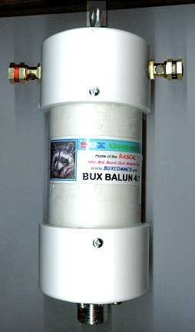
50 ohm, SO-239 unbalanced input
Balanced output
1.6 to 50 MHz
Power Rating; 500 Watts PEP
Toroid design, wound with teflon covered, silver plated wire.*
Heavy-Duty, Lightweight, construction.
Sealed against moisture
Top Quality Brass Antenna Connections
SO239 input connector is Silver with Teflon™ insulator.
4:1 Balun, Order No. BUXBALUN 41 $19.95
1:1 Balun, Order No. BUXBALUN 11 $19.95
BUX UN UN De-Coupling transformer, similar to above, but has SO-239 (female)input connector and output connector is 1 ft Mini 8 cable with PL-259 (male).
Order No. BUX ONION $19.95
In addition to the above baluns, we build the BUX BALUN 41* rated at the "legal-limit"
ORDER No., BUX41LL $34.95
*We don't cut corners! The components used in the manufacture of these BALUN are top quality, beginning with the SO239 connectors which are silver plated, and a teflon™(E.I Dupont) center insulator. The wire we use to wind the ferrite donut is a heavy, silver flashed, wire that will handle RF voltages above 5000 volts. The wire is teflon™ coated to withstand temperatures above 2000 degrees.

ANTENNA INSULATORS
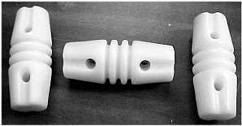
Weatherproof, (TENYTE) insulators. Perfect for your DIPOLE or Windom antenna.
For the apartment dweller, you can now hang the 20 meter doublet
in the attic. I've QSO'd with stations all over the world with the
33 ft dipole in my garage attic.
One insulator at the center, and one each end.
It's great for other HF WINDOM and single-band dipole antennas.
Dielectric strength is comparable to the old ceramic insulators,
without susceptibility to cracking or breakage under impact or
extreme temperature changes.
Package of 3, $3.95 Order No. 3INSULTR
Package of 10, $10.95 Order No. 10INSULTR
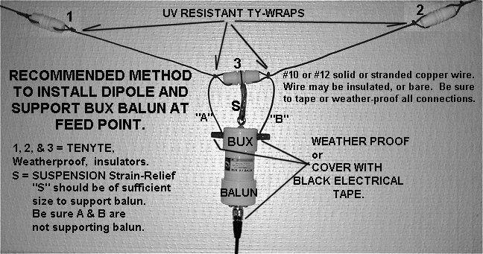
SECURE, On-line order form, Click Here!
FAX or Mail order form, Click Here!
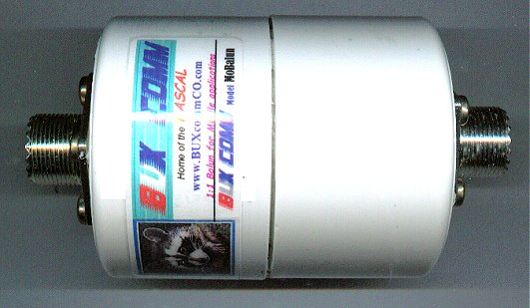
BUX MOBALUN
When you hear those strong HF mobile signals, here's one reason they stand out from the rest. By installing the BUX MoBalun near the input to your antenna, you deliver more RF energy to the antenna. At the same time, the BUX MoBalun prevents RF from traveling back along the shield (high SWR) of your coax. High power rating, Low-permeability toroid, Current type, with Internal fiber-glass composition to prevent vibration during mobile operation. For input and output, we use only the best Silver plated, Teflon™ insulated,
SO239 connectors. 500 watts PEP
$19.95 Order No. MOBALUN
CLICK HERE for MORE Antennas, Accessories, Components, & Connectors Click HERE, for TNC to Radio Interface Cable Diagrams !
Click HERE, for PSK31 & SSTV Interface Diagrams !
Back to www.PacketRadio.com
CLICK HERE for Accessories, Antennas, Components, Connectors & Power cords
Web Page Design and HTML By
G. E. 'Buck' Rogers Sr K4ABT d/b/a BUX CommCo™® ©
Copyright © 1996-2003
All Rights Reserved
BUX CommCo™®
115 LUENBURG DRIVE
EVINGTON, VIRGINIA 24550
FAX 434 525 7818
""

