HF MOBILE ANTENNA (HB9ABX)
Felix Meyer
update 27th May 2003 / details 12th Oct. 2003

This mobile antenna is designed for all HF bands from 10 to 80 meters an proved to be very efficient in my travels in South America on 15 and 20m for contacts to Europe and within South America.
The antenna is my own development. Compared to commercial HAM Antennas the performance was always much better, due to the larger size and lower loss in coil.
In field tests we compared 3 different mobile antennas, all at the same location, at the same time, each one with 100 W power.
The 3 antennas were:
- HUSTLER mobile antenna (10 - 80 m)
- YAESU ATAS-100 (10 - 40 m)
- HB9ABX mobile antenna (10 - 80 m)
In all tests the signal of the home made antenna was the strongest!
- 1 S points (up to 10 db) stronger than HUSTLER
- 2 to 3 S points stronger than ATAS-100/ATAS-120
These results in the ground wave (5 to 10 km), as well as in the far field at 70 km to 1000 km distance.
For 10, 15, and 20 m the antenna consists of a fixed lower part and an extensible whip (telescopic antenna of 15 to 80 cm length) on the top. For 20, 40 and 80m a second segment is added and at the top follows the whip.
Both parts are made of fiberglass rod of 10 mm diameter and 175/165 cm length, on which a piece of enameld copper wire (CuL) of 1.5mm diameter is wound. Aluminium tubes are used to join the parts together. On both fiberglass rods equally spaced windings of emameld copper wire of 1.5 mm dia are wound. The lower part holds 320 cm wire (79 turns) and the upper part holds 470 cm wire (120 turns).
The loading coil is wound on a plastic tube of 7.5cm diameter and 17 cm length. The same type of wire (1.5 mm CuL) is used for the coil as for the antenna. The coil has 33 turns in total, coil length is 12 cm. Seen from the bottum of the coil, there are taps at 21, 27, and 33 turns, which are shorted according to the operating frequency.
Settings of the antenna in operation:
10m : Lower part + whip + tap 3 + bridge from tap 3 to the whip
15m : Lower part + whip + tap 3
20m : Lower part + whip + tap 2
20m : Both parts + whip + tap 3
40m : Both parts + whip + tap 1
80m : Both parts + whip + no tap (full coil)
The WARC bands 30, 17, and 12 m can be operated by just adding coil taps without changing the coils.
Feeding:
The antenna is fed by 50 Ohm coax (Type RG 58) of about 2 m length. On the antenna side the center conductor of the coax is connected to the antenna wire and the coax braid is connected to the car chassis ground.
The antenna system requires a good ground !
I soldered a flexible wire at both sides inside the door frame leading to the coax braid.
Don't forget to connect the two windings on the fiberglass rod together, either through the metal sleeve between the rods, or simply by a connector. The whip on the top is connected to the end of the wire below.
The desired resonance frequency is adjusted by changing the length of the whip on top of the antenna. Extending the whip lowers the frequency.
The antenna requires an antenna tuner for operation, as the impedance differs from 50 Ohms on 40 and 80 m. With the aid of the tuner, the antenna is adjusted to SWR 1.0 on all bands.
The MFJ-901B tuner is fine for this use. It has little weight and is very small (12.5 x 5 x 15 cm).
(Before its use it's recommended to open it to check the adjustment of the variable capacitors. They are frequently bad centered, which produces easily shorts ...)
If the transceiver and tuner are without SWR meter then a separate instrument is to be connected between TX and tuner. I am using a DAIWA CN410M which is a small cross needle instrument best suited for this use.
Mounting of the antenna:
I installed the antenna on top of the car on a roof carrier. Two aluminum angles, 30 cm length, 30mm thigh, were fixed with screws to the carrier and the rod below the coil fixed to the angles
by means of two hose clamps.
Instead of the Aluminium tubes copper tubes may be used, whatever is found to be better. The tubes are glued in 5 cm length over the fiberglass rod. At the end of the 7 cm open part of the tube, a 2 cm long slot is sawed and a small clamp is used to hold the inserted antenna part .
The antenna is directed backwards at an angle of abt. 70 degrees. In order to prevent swinging up, the antenna is fixed slightly down at the end with a nylon rope. Use 2 nylon ropes, to both sides to prevent swinging sidewise when driving. This is required when both antenna elements are installed.
The top of the antenne nearly reaches 3.2 m height above ground when both elements are in use and fixed by a nylon.

Adjustment hints:
Initially, the antenne has te be tuned to resonance on each band without using the tuner.
This adjustment is done by changing the coil tabs and then varying the spacing between turns.
In operating mode, only the tab setting is changed, the whip length set, and tuned with the tuner.
Before initial adjustment, both elements have to be checked: click here
The initial adjustment is done by using an antenna analyzer (e.g.MFJ-259).
Resonance is found by obtaining minimum SWR on the instrument.
Procedure of initial adjustment : (this is done without tuner)
Lower part + whip (10 to 20 m)
- Coil tap 3 ( = all turns closed)
Adjust length of whip to obtain min. SWR at 21.2 MHz.
Note length of whip. This is the 15 m setting.
- Coil tap 2 (27 turns closed)
Keep length of whip from previous setting.
Adjust spacing of the upper 6 turns to obtain min. SWR at 14.2 MHz.
Fix coil, this is the 20 m setting.
- Coil tap 3
Make a bridge using a flexible wire of 150 cm length with clips
between tap 3 to whip connection (wound 2 - 3 times around rod).
Adjust length of whip to reach min. SWR at 28.4 MHz.
Note length of whip. This is the 10 m setting.
Both parts + whip (20 to 80 m)
- Coil tap 3
Adjust length of whip to reach min. SWR at 14.2 MHz.
Note length of whip. This is the 20 m setting.
- Coil tap 1
Measure SWR on 7.05 MHz and adjust spacing of coil between taps 1 and 2 to reach minimum SWR. Change length of whip only, if minimum SWR remains outside indicated frequency.
Fix coil and note length of whip. This is the 40 m setting.
- Coil without tap (33 turns active).
Keep length of whip and measure SWR on 3.7 MHz.
Adjust spacing of coil of the first 21 windings to reach miminum SWR.
Change length of whip only, if min. SWR remains outside 3.7 MHz.
Fix coil and note length of whip. This is the 80 m setting.
After terminating this adjustment the coil winding is fixed permanently.
After this initial adjustment, the tuner is connected to mach the SWR exactly on operating frequency.
With my antenna the SWR without tuner on 10, 15, and 20 m is better than 1.2 therefore tuning is only required for 40 m and 80 m operation. This however depends from the actual installation, especially from the ground connection.
See further details from the following drawings:
Drawing 1 (lower part)
Drawing 2 (upper part)
The photograph below shows the installed antenna in Chile as CE3CWF/mobile.
(The white antenna is a 2m antenna)
Good luck in construction. For additional questions: see here
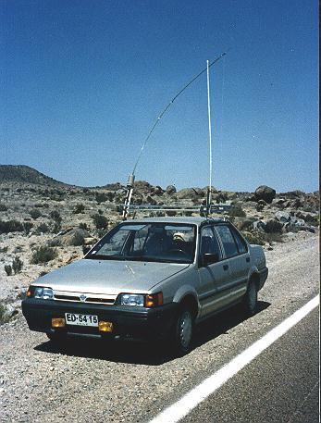 my antenna as CE3CWF
Below the mobile antenna in Switzerland as HB9ABX:
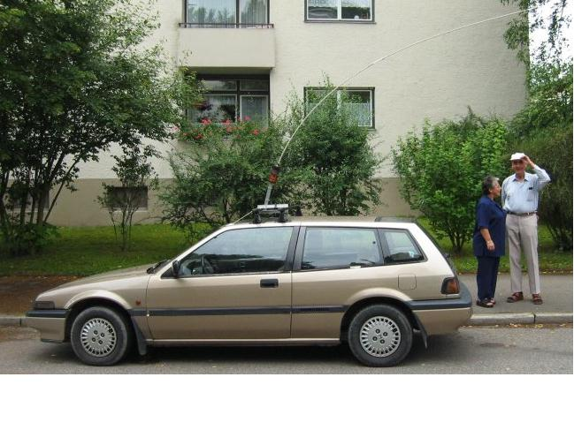
And finally the mounting of the antenna on the roof of the car:
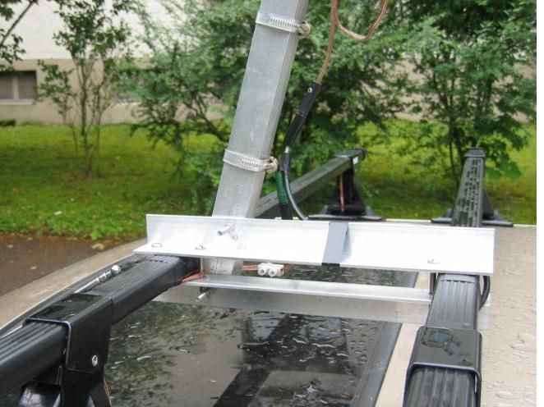
WARNING.....!
Working with fiberglass rods produces dangerous dust, which easily produces allergies on the hands. Inhalation of the dust is extremly dangerous !
Already holding the raw bars with the hand can produce problems, therefore use protecting gloves whenever working and handling raw fiberglass rods and observe appropriate care when sawing.
Wash well the hands with soap after the work !
After terminating the work paint the complete rods with a suitable lacquer to protect the surface.

