http://www.tubes.ru/techinfo/AmateurRadio/gu-81m.html
GU-81M
PENTODE
The GU-81M pentode is used in self-excited oscillation and power amplification circuits of RF equipment.
GENERAL
Cathode: directly heated, carbonized thoriated tungsten.
Envelope: glass, with base.
Height: at most 260 mm.
Diameter: at most 202 mm.
Mass: at most 1 kg.
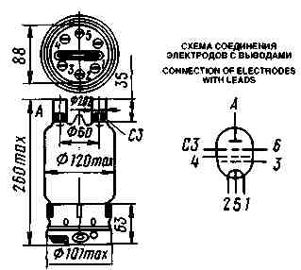
1, 2 - cathode; 3 - grid 1; 4 - grid 2; 5 - cathode centre tap; 6, C3 - grid 3; A - anode
OPERATING ENVIRONMENTAL CONDITIONS
Ambient temperature, °C | -10 to +55
Relative humidity at up to +25 °C, % | 98

BASIC DATA
Electrical Parameters
Filament voltage V | 12.6
Filament current, A, at most | 11
Mutual conductance (at anode voltage 2 kV, grid 2 voltage 600 V, anode current 200 mA), mA/V | 4.5-6.5
Gain coefficient (grid 1 -grid 2) (at anode voltage 2 kV, grid 2 voltages 600 and 500 V, anode current 200 mA) | 2.5-4
Bias voltage (at anode voltage 2 kV, grid 2 voltage 600 V), V | 116-160
Interelectrode capacitance, pF:
input | 25-32
output | 21-26
grid 1-anode, at most | 0.1
grid 1-grid 3 | 1-4
Output power (at anode voltage 2 kV, grid 2 voltage 600 V, bias voltage -200 V, grid 1 drive voltage amplitude 300 V, anode current, at least 450 mA, grid 1 current at most 20 mA, grid 2 current, at most 220 mA), W, at least | 700

Limit Operating Values
Filament voltage, V | 11.6-13.4
Anode voltage, V:
at frequencies not above 6 MHz | 3
at frequencies not above 24 MHz | 2.5
at frequencies not above 50 MHz | 1.5
Grid 2 voltage, V | 600
Anode current (average value), A | 0.6
Grid 1 current (average value), A | 0.02
Grid 2 current (average value), A | 0.2
Dissipation, W:
anode | 450
anode (momentary dissipation) | 600
grid 2 | 120
grid 1 | 10
Envelope temperature, °C | 350
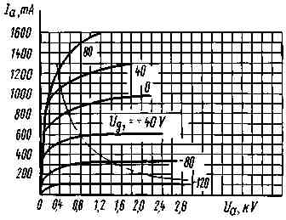
Averaged Anode Characteristic Curves:
U_{f} = 12.6V; U_{g2} = 0.5kV;
— • — (P_{a max})
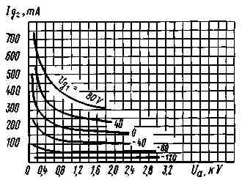
Averaged Grid 2-Anode Characteristic Curves:
U_{f} = 12.6V; U_{g2} = 0.5kV
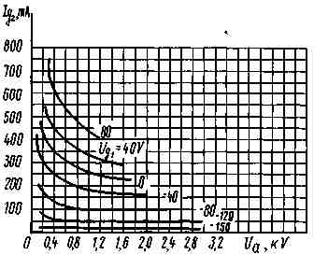
Averaged Characteristic Curves:
U_{f} = 12.6V; U_{g2} = 0.6kV
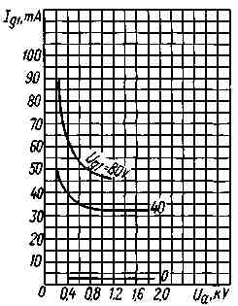
Averaged Grid-Anode Characteristic Curves:
U_{f} = 12.6V; U_{g2} = 0.5kV
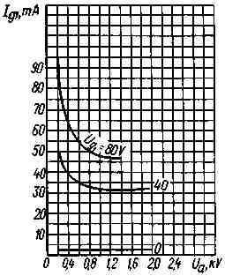
Averaged Grid-Anode Characteristic Curves:
U_{f} = 12.6V; U_{g2} = 0.6kV

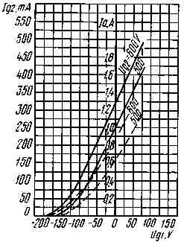
Averaged Characteristic Curves:
U_{f} = 12.6V; U_{a} = 2.5kV;
_____ anode-grid;
_ _ _ grid 2
Main Menu | All Types | Contact Us | Order Form | Warranty | Quality | Company Profile

