Besleme sekline gore Delta Loop polarizasyonu

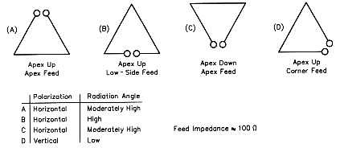
Calculated wire lengths at mid-band
10 meters | 34.835 feet
12 meters | 40.296 feet
15 meters | 47.349 feet
17 meters | 55.469 feet
20 meters | 70.546 feet
30 meters | 97.185 feet
40 meters | 140.559 feet
75/80 meters | 269.798 feet
160 meters | 528.947 feet

