**http://www.eleccircuit.com/image/cat.jpg300W inverter power 24Vdc to 220Vac by MJ15003,CA3130,CD4027**

This is circuit 300W Inverter power,so input battery 24V to Output 220Vac 50Hz 300W. I used main Component IC CD4027 , NE555,CA3130 and LM7805. The transistor power MJ15003,**2N3773** driver transformer 24V 10A min. The VR1 – 100K is control Frequency output at 50Hz 50Hz or 60Hz at Square wave signal.  
The VR2 – 50K is control voltage output at 220V.  
**Note:**  
C6 = 0.1uf metalized-film capacitor, 5% tolerance.  
Please read more in image circuit.

[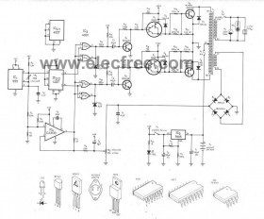](http://www.eleccircuit.com/wp-content/uploads/2008/06/300w-inverter-24vdc-to-ac220vac-circuit-by-ne555ca3130mj15003.jpg)

[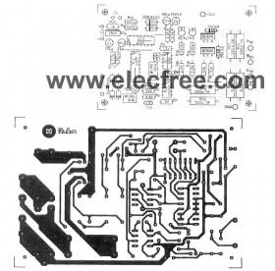](http://www.eleccircuit.com/wp-content/uploads/2008/06/300w-inverter-24vdc-to-ac220vac-pcb-by-ne555ca3130mj15003.jpg)  
  
**PCB:300W inverter power 24Vdc to 220Vac by MJ15003,CA3130,CD4027**

**Related Posts :**