**110 - 140Mhz Hava Bandı AM Alıcı**

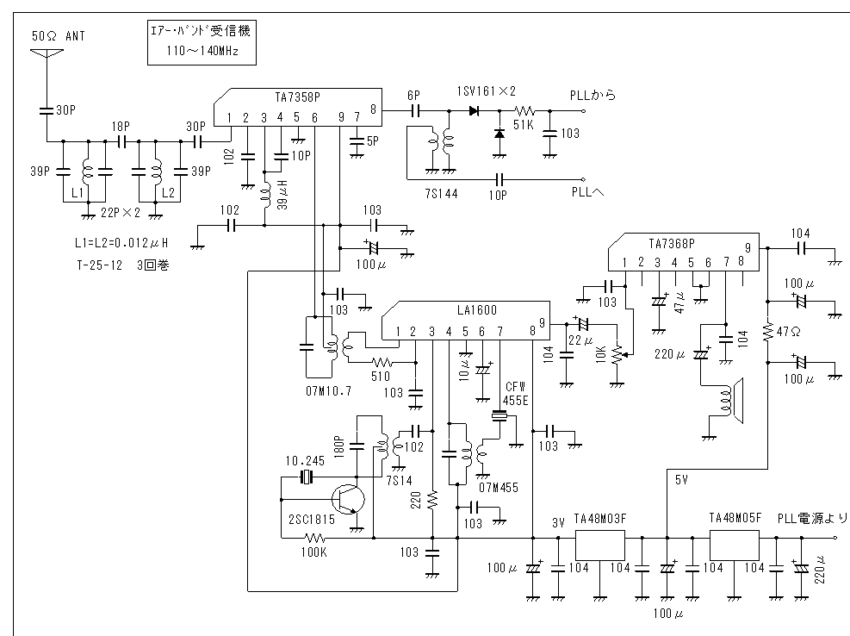

KAYNAK KOD:

' PIC 16F877 VHF air radio Program

'-------------------------------------------------

channel var word

bunnsyuu var word

var byte

rb var byte

rd var byte

keta0 var byte

keta1 var byte

keta2 var byte

keta3 var byte

keta4 var byte

hyouzi0var byte

hyouzi1var byte

hyouzi2 var byte

hyouzi3 var byte

hyouzi4 var byte

'-------------------------------------------------

Define LCD_DREG PORTC ' Set LCD

Define LCD_DBIT 4

Define LCD_RSREG PORTC

Define LCD_RSBIT 2

Define LCD_EREG PORTC

Define LCD_EBIT 3

Define LCD_BITS 4

'-------------------------------------------------

ADCON1 = 7 ' Set PORT DIGITAL

'-------------------------------------------------

TRISA = %00000 ' Set PORT

TRISB = %00000000

TRISC = %00000000

TRISD = %00000000

TRISE = %110

'-------------------------------------------------

Pause 500

channel = 12500

bunnsyuu = 2286

gosub lcd

goto main

'--------------------------------------------------

lcd: keta0 = bunnsyuu DIG 0

keta1 = bunnsyuu DIG 1

keta2 = bunnsyuu DIG 2

keta3 = bunnsyuu DIG 3

rd = keta1 * 16 + keta0

poke portd,rd

rb = keta3 * 16 + keta2

poke portb,rb

hyouzi0 = channel DIG 0

hyouzi1 = channel DIG 1

hyouzi2 = channel DIG 2

hyouzi3 = channel DIG 3

@hyouzi4 = channel DIG 4

Lcdout $fe, 1, "AirBand Receiver"

Lcdout $fe,$C0," ",#hyouzi4,#hyouzi3,#hyouzi2,$2e,#hyouzi1,#hyouzi0," ",$4d,$48,$7a

return

'--------------------------------------------------

main: if porte.1 = 0 Then up

if porte.2 = 0 Then down

goto main

'-------------------------------------------------

up: Pause 50

if porte.1 = 0 Then up1

goto main

up1:pause 50

i = 0

for i = 1 to 20

if porte.1 = 1 then up3

i = i + 1

pause 50

next i

while porte.1 = 0

channel = channel + 5

bunnsyuu = bunnsyuu + 1

if bunnsyuu <= 2586 Then up2

channel = 11000

bunnsyuu = 1986

up2:pause 20

gosub lcd

wend

goto main

up3:channel = channel + 5

bunnsyuu = bunnsyuu + 1

if bunnsyuu <= 2586 Then up4

channel = 11000

bunnsyuu = 1986

up4: gosub lcd

goto main

'-------------------------------------------------

down: Pause 50

if porte.2 = 0 Then down1

goto main

down1: pause 50

i = 0

for i = 1 to 20

if porte.2 = 1 then down3

i = i + 1

pause 50

next i

while porte.2 = 0

channel = channel - 5

bunnsyuu = bunnsyuu - 1

if bunnsyuu >= 1986 Then down2

channel = 14000

bunnsyuu = 2586

down2: pause 20

gosub lcd

wend

goto main

down3: channel = channel - 5

bunnsyuu = bunnsyuu - 1

if bunnsyuu >= 1986 Then down4

channel = 14000

bunnsyuu = 2586

down4: gosub lcd

goto main

'-------------------------------------------------

HEX :

:10000000B401EB28A501A400B5172730A3001030D8

:1000100015200330A300E8301520A301643015201B

:10002000A3010A30152024082028A2002508A100D9

:100030002408A000B4202008031DB513B51B080038

:10004000303EA7008711071107118316871107118A

:1000500007110F30870583122708B4184D283A304E

:10006000A100983080203330A60061201330A10019

:1000700088308020612064307F20612064307F20C0

:100080002230A600612028304C200C304C20063055

:100090004C20B41427084D283414A600341C5B28C7

:1000A0000711033C031C602860200730A100D030FA

:1000B0008020031408003414FE3C0319E6280715B9

:1000C000341C341087150F3087052608F039870453

:1000D0008711A60E3418612832307F2003140800DF

:1000E0008000E628A301A200FF30A207031CA3079B

:1000F000031CE6280330A100DF3080207428A10112

:10010000E83EA000A109FC30031C8928A0070318C1

:100110008628A0076400A10F862820188F28A01C1D

:100120009328000093280800013EA7000A30A2008F

:10013000A301B420A70B992824080800A2000330CB

:10014000A428A2000630A428A80023082102031D29

:10015000AB282208200204300318013003190230B2

:100160002805031DFF30E628A501A4011030A600D4

:10017000210DA40DA50D2208A4022308031C230FA2

:10018000A5020318CA282208A40723080318230F6E

:10019000A5070310A00DA10DA60BB8282008E6287E

:1001A0001030A800A101A001A70CA60C031CDE289A

:1001B0002208A00723080318230FA107A10CA00CF5

:1001C000A50CA40CA80BD4282408E6288313031339

:1001D000831264000800831607309F0085018601A2

:1001E000870188010630890083120130A300F430B2

:1001F0008A017320D430BC003030BD00EE30BA002C

:100200000830BB008A110A1208218A110A12D42967

:100210003A08A0003B08A10000308A019420C400E5

:100220003A08A0003B08A10001308A019420C500D3

:100230003A08A0003B08A10002308A019420C600C1

:100240003A08A0003B08A10003308A019420C700AF

:100250004508A600A7011030A200A3018A01D02002

:10026000B2002508B30044083207CA004A088800D3

:100270004708A600A7011030A200A3018A01D020E0

:10028000B2002508B30046083207C90049088600B5

:100290003C08A0003D08A10000308A019420BE0067

:1002A0003C08A0003D08A10001308A019420BF0055

:1002B0003C08A0003D08A10002308A019420C00043

:1002C0003C08A0003D08A10003308A019420C10031

:1002D0003C08A0003D08A10004308A019420C2001F

:1002E000FE308A01212001308A01212041308A011B

:1002F000212069308A01212072308A012120423078

:100300008A01212061308A0121206E308A0121205A

:1003100064308A01212020308A01212052308A0154

:10032000212065308A01212063308A012120653037

:100330008A01212069308A01212076308A0121201A

:1003400065308A01212072308A012120FE308A0125

:100350002120C0308A01212020308A012120203034

:100360008A01212020308A01212042088A010220AE

:1003700041088A01022040088A0102202E308A01A9

:1003800021203F088A0102203E088A0102202030F5

:100390008A0121204D308A01212048308A01212004

:1003A0007A308A012120080064008A110A12891C0F

:1003B000E02964008A110A12091D4F2A8A01D429F2

:1003C00032308A01722064008A110A12891CEA29DB

:1003D0008A01D42932308A017220C3010130C3005E

:1003E0006400153043028A110A120318052A6400BA

:1003F0008A110A1289182F2AC30A32308A01722000

:10040000C30A8A110A12031DF02964008A110A1214

:1004100089182D2A0530BC070318BD0ABA0A03192A

:10042000BB0A3A08A0003B08A1000A30A3001A301A

:100430008A01A1208A110A12031D262AF830BC0065

:100440002A30BD00C230BA000730BB0014308A0128

:1004500072208A0108218A01052A8A01D4290530DF

:10046000BC070318BD0ABA0A0319BB0A3A08A00060

:100470003B08A1000A30A3001A308A01A1208A118A

:100480000A12031D4B2AF830BC002A30BD00C230CE

:10049000BA000730BB008A0108218A01D429323012

:1004A0008A01722064008A110A12091D592A8A01E0

:1004B000D42932308A017220C3010130C3006400A4

:1004C000153043028A110A120318742A64008A1133

:1004D0000A120919A32AC30A32308A017220C30AF8

:1004E0008A110A12031D5F2A64008A110A1209196F

:1004F000A12A0530BC020030031C013EBD020130C0

:10050000BA020030031C013EBB023A08A0003B08BF

:10051000A1000730A300C2308A019E208A110A126E

:10052000031D9A2AB030BC003630BD001A30BA0024

:100530000A30BB0014308A0172208A0108218A0126

:10054000742A8A01D4290530BC020030031C013E04

:10055000BD020130BA020030031C013EBB023A0862

:10056000A0003B08A1000730A300C2308A019E20F2

:100570008A110A12031DC42AB030BC003630BD00F7

:100580001A30BA000A30BB008A0108218A01D42936

:0605900063008A01C82A85

:02400E00753FFC

:00000001FF

