**100 Watt FM Power 2SC1946 - 2SC2782**

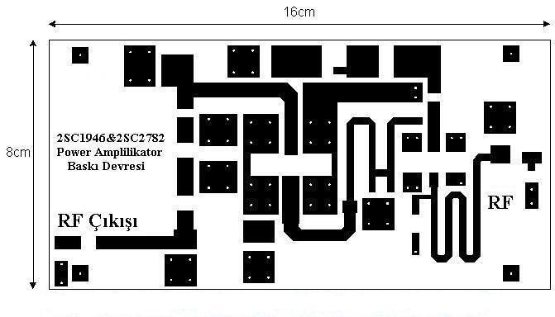

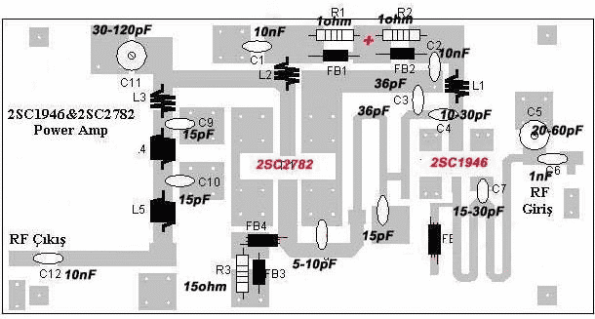

|  |  |
| --- | --- |
| *R1, R2* | *1 ohm/ 1/2 watt, karbon* |
| *R3* | *15 ohm/ 1/4 watt karbon* |
| *C1, C2, C12* | *10nf, keramik* |
| *C3* | *36pf, silver mica* |
| *C4* | *22pf, 15pf keramik diparalel kapasitor variable 25pf* |
| *C5* | *60pf, kapasitor variable (plastik)* |
| *C6* | *1nf, keramik* |
| *C7* | *34pf, 22pf, 15pf kermik diparalel* |
| *C8* | *15pf, kermaik* |
| *C9, C10* | *15pf, silver mika 250v* |
| *C11* | *120pf, kapasitor variable* |
| *L1, L3* | *Tembaga 1 mm, diameter 5 mm, 3 lilit* |
| *L2* | *Tembaga 1.2 mm, diameter 5 mm, 3 lilit* |
| *L4, L5* | *Tembaga 1 mm, diameter 5 mm, 6 lilit* |
| *FB1, FB2,FB3* | *2 Ferrite bit diseri* |
| *FB4, FB5* | *1 Ferrite beat (6 lubang), dililit tembaga 1 mm sebanyak 2 lilit* |