**http://www.eleccircuit.com/image/cat.jpg5 channel graphic equalizer by BC548 transistor**

The graphic equalizer circuit the frequency adjust circuit. For some kinds of audio frequency response is not smooth. The frequency offset by the tone controls, may not work well. Because the bandwidth is too wide. , Requiring the use of e-equalizer circuit with a narrow bandwidth and is divided into frequency bands increased to 5 channels or more can be broken down to specific actions required frequency bands have to be more specific.

The equalizer circuit can adjust the frequency to 5 channel is 60 Hz, 100 Hz, 1 kHz, 3 kHz and 12 kHz. When entering input signal to signal coupling d through C1 to the position pin 1 of VR1-VR5. If the VR to adjust the position of a signal pin will go to where the second pin of the VR is going through a lot this signal high-frequency filter – a low of each channel. The frequency of each channel is determined by the R1-R8, and C2-C9. And then the signal will pass filter for each channel will be combined coupling d through C10 to expand with the Q1 and Q2. Which Commonwealth model for circuit E Foster limit expansion of output pins of Q2 via C13 C into the output signal. Signals and the other part is fed back via R12 to enter a location pins 3 of the VR1-VR5 and adjusting VR through this terminal signal input to the phase opposite and will cancel the input signal at that point. This is the Cut.  
Implementation is very simple. Just pre intermediate tone with the power amp. If the system is used in stereo, then build up to another set.

[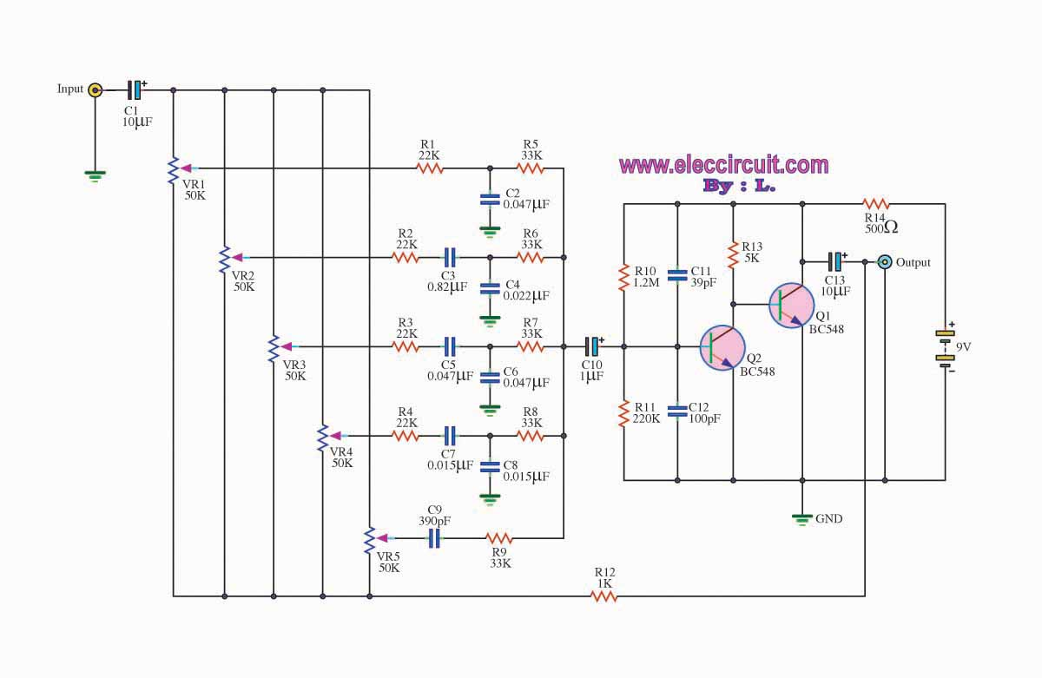](http://www.eleccircuit.com/wp-content/uploads/2010/12/5-channel-graphic-equalizer-by-bc548-transistor.jpg)

**Related Links**  
[**Stereo graphic equalizers**](http://www.eleccircuit.com/tag/stereo-graphic-equalizers/)[**Graphic equalizer**](http://www.eleccircuit.com/tag/graphic-equalizer/)[**Transistor equalizer circuit**](http://www.eleccircuit.com/tag/transistor-equalizer-circuit/)  
[5 Channels Graphic Equalizer by LA3600](http://www.eleccircuit.com/5-channels-graphic-equaliser-by-la3600/)  
[5 Channels 2 Octave Graphic Equaliser by 4558](http://www.eleccircuit.com/5-channels-2-octave-graphic-equaliser-by-4558/)  
[10 Channel Graphic Equalizer by LA3600](http://www.eleccircuit.com/10-channels-graphic-equaliser-by-la3600/)  
[Tone Control Stereo (bass-treble) by IC NE5532 x2.](http://www.eleccircuit.com/tone-control-stereo-bass-treble-by-ic-ne5532-x2/)