**http://www.eleccircuit.com/image/cat.jpgPower Amp Super Bridge 120W by IC TDA2030**

**This be Super Bridge 120W Power Amplifier by IC TDA2030 for you like the circuit amplifies that use the integrated circuit. and Transistor BD249 or TIP31 or TIP41 or C1061 and BD250 or TIP32 or TIP42 or A671. It is nice circuit and easy to use.**

[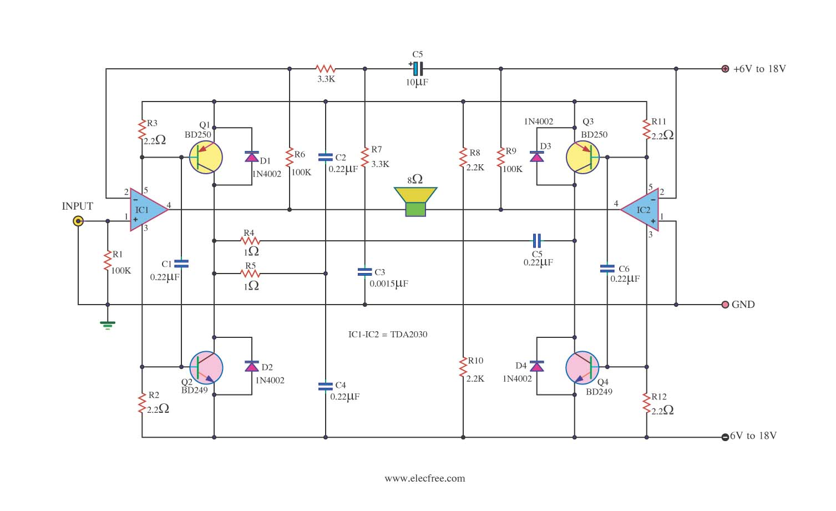](http://www.eleccircuit.com/wp-content/uploads/2009/08/power-amp-super-bridge-120w-by-ic-tda2030.jpg)  
**circuit Power Amp Super Bridge 120W by IC TDA2030**

[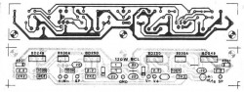](http://www.eleccircuit.com/wp-content/uploads/2009/09/pcb-power-amp-super-bridge-120w-by-ic-tda2030.jpg)  
**PCB Power Amp Super Bridge 120W by IC TDA2030**

This circuit is designed by using TDA2030A circuit as driver to power transistor output to applied to out up 30 watt.  
- then take both circuit to bridge together, makes we have the power output up to 4 times and have even maximum power output is 200Watt.

May don’t be defeated because this circuit give the electric power about 120W that load 2 ohm. When see the circuit will think use important equipment be. Must use power supply source that be appropriate about +15V and -15V that current 2Amp. Besides should use heat sink at have the size is appropriate IC TDA2030 and Q1-Q4 [**BD249**](http://www.eleccircuit.com/tag/bd249/),[**BD250**](http://www.eleccircuit.com/tag/bd250/) for see the circuit has already. Build easy must not fine decorate anything. Request a friend has fun Power Amp Super Bridge 120W by IC TDA2030 please sir.

- The advantage of this circuit, the voltage of the power supply is low (compared to other circuits. Watts are equal in size), so I used the low voltage capacitor, smaller, and cheaper.  
- As can be seen from the circuit, we enter a signal input at pin 1 is side single. With pin 1 of IC2 (TDA2030) is connected to ground, And the output signal fed back to the inverting pin (pin 2) of IC2, Allow us to signal with opposite phase, input to the amplifier is one automatically.  
 **How to build**  
Soldering Electronic Components to the right, onto the PCB as shown in Figure 2. Then install the power transistor to the heat sink. By Vice insulating sheet mica. To prevent a short circuit on the heat sink neatly.  
When certain everything must be right, it was the power supply to the circuit, in order to use it, without having to adjust the circuit.  
 **Detail of circuits**  
Q1,Q3_________BD250___PNP POWER TRANSISTORS(25A,125W)  
Q2,Q4__________BD249____NPN POWER TRANSISTORS(25A,125W)  
D1,D2,D3,D4____1N4002____Diode 1A 100V  
IC1,IC2_________TDA2030A__18W HI-FI AMPLIFIER AND 35W DRIVER  
R1,R7,R11,R13__2.2 ohm____Resistors 1/2W  
R2,R3,R12______100K______ Resistors 1/4W  
R4,R8__________2.2K_______ Resistors 1/4W  
R5,R6__________3.3K_______ Resistors 1/4W  
R9,R10_________1 ohm______ Resistors 1/2W  
C1_____________0.0015uF 50V___ Polyester Capacitor  
C2,C3,C4,C5,C7_0.022uF 50V___ Polyester Capacitor  
C6_____________10uF 16V_____ Electrolytic Capacitors