**http://www.eleccircuit.com/image/cat.jpgHigh power transistor amplifier circuits**

**300Watt audio amplifier HIFI by MJ15003-MJ15004 Transistor**  
Follow the request of friends who likes High power Amplifier Circuit. I then beg for to advise this circuit. It has can to give the electric power about 300Watt RMS unless. Still be amp OCL Model Class AB give sound tall power and certainly should systematically protect that excellent a loudspeaker then torn difficult. Besides still use Transistor replace the integrated circuit then give waste matter feeling cancels bland three goes up and have MJ15003 and MJ15004 then have respond electric good enough power. When friends see the circuit has already , will have plentiful detail,then inappropriate for hobby Electronics man type. But if friends want to try build , have no a problem , be lucky.

[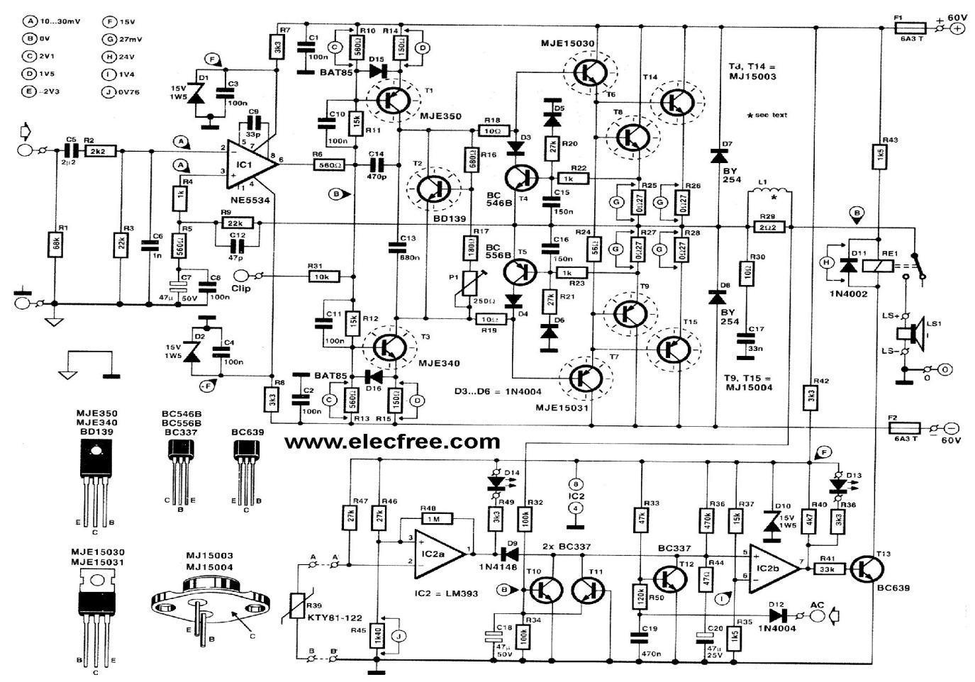](http://www.eleccircuit.com/wp-content/uploads/2008/09/300watt-audio-amplifier-hifi-by-mj15003-mj15004-transistor.jpg)

**200 Watt power Amplifier for car by 2SC2922+2SA1216**

Today we try to come to see the idea power Amplifier for Car. I sees this circuit , designed come to well. There is tall drive arrives at 200W is the character Amp OCL very be Class AB amplifier make good moderately sound. Besides still systematically protect excellent loudspeaker. But I thinks this circuit may inappropriate with a novice. Because of use many equipments, circuit absorb overlap , must fine decorate thoroughly. But friends at like sound good quality As a result be worthwhile very. See be circumspect in power Amplifier for car circuit get yes.

[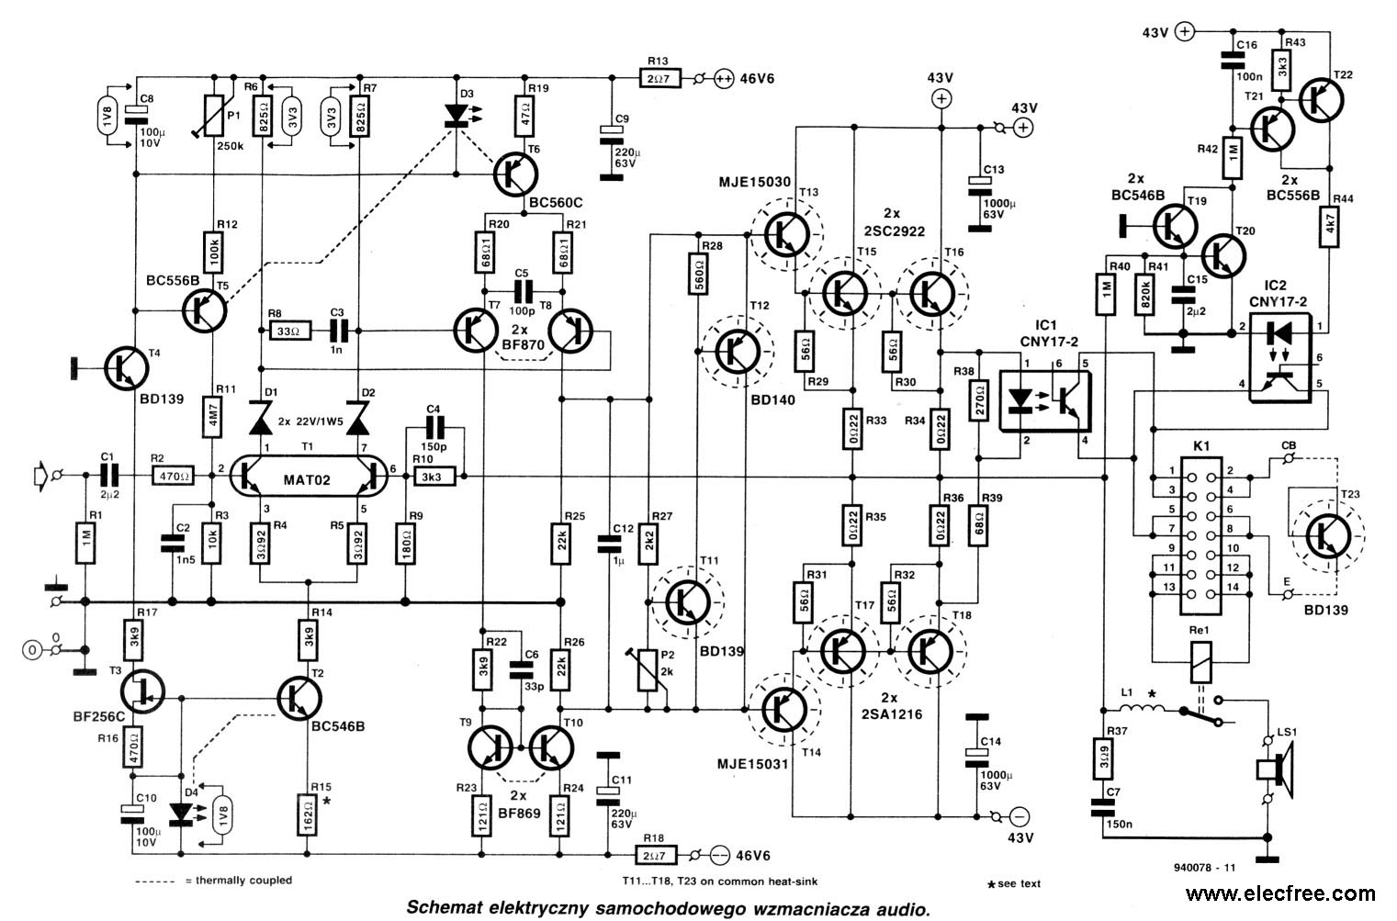](http://www.eleccircuit.com/wp-content/uploads/2008/09/200-watt-power-amplifier-for-car-by-2sc29222sa1216.jpg)