**http://www.eleccircuit.com/image/cat.jpg100 watt DC servo amplifier by Power MOSFET**

This is circuit MOSFET power amplifier OCL, Output 100w , use mosfet k134+j49 or Mosfet J162 + K1058, Output 112W at Speaker 8 OHM. Power Supply +56V/-56V 4A /Ch.

For those who want to profanities fun. This 100 watt power mosfet amplifier series be able to you for sure. And can have a most sound frequencies response. If You think that, I say the truth, then invite you to consider this Circuits. And build as needed.

**How it works**  
From a first circuit, will seen that characteristics of the circuit is similar to the OP-AMP power circuit, by a positive input for the signal input enters, and has input for connect a feed back signal.

This circuit can woks well, even at low frequencies alike DC signal. So we may be called “DC Amplifier circuit”. Which can be applied in the servo amplifier as well.  
The gain of this circuit depends on the R8/R7, From values in the circuit to has amplify rates equal to 22, which means that If there is a input signal size 1 volt Have output voltage is 22 V.  
From Ohm’s law, can calculate the power output be equal : Power = (ExE)/R = 22 x 22 / 8 = 66.5 watt at load 8 ohm.  
or = 120 watt at load 4 ohm.

[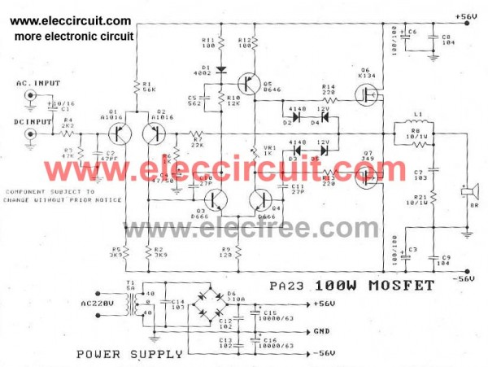](http://www.eleccircuit.com/wp-content/uploads/2012/09/The-circuit-of-100-watt-dc-servo-amplifier-by-power-mosfet.jpg)  
**The circuit of 100 watt DC servo Amplifier by Power MOSFET**

So if you want to output 100 watt at load 8 ohm, we will need to enter the input signal is not lower than 1.28V.  
The transistor Q5 as constant current Circuits, so Bias of output mosfet, so it can be adjusted by adjusting VR1, and to make the Circuits more good stability, The VR1 should be chosen carefully so as CERMET.  
At gate of output mosfet is a zener diode to prevent the input signal is higher than 14V, Because mosfet will be damaged.

**The MOSFET runaway thermal.**  
The advantages of the MOSFET power amplifier circuit that we know very well is to prevent over load by itself.  
- That is, when the over load, will higher the temperature of MOSFET but values resistance of the MOSFET then be higher. (In normal transistors, the resistance will decrease.) As a result, the current through the MOSFET lower  
- If install the heat sink the appropriate size, then can be easily shorted output, by the MOSFET will not be damaged.  
The most important factor, which will make circuits work to its full potential is the power supply Circuits. We suggest using the power supply separately, for each amplifiers. The advantage of this power, is that it helps reduce cross talk and low frequencies as well.

The transformer should be able to provide the current at secondary coil than 3 Amp and has voltage output at 40 Volt center trap as well.

[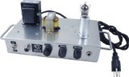](http://www.amazon.com/gp/product/B00493YF8W/ref=as_li_ss_il?ie=UTF8&camp=1789&creative=390957&creativeASIN=B00493YF8W&linkCode=as2&tag=circuprojeele-20)http://www.assoc-amazon.com/e/ir?t=circuprojeele-20&l=as2&o=1&a=B00493YF8W[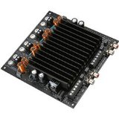](http://www.amazon.com/gp/product/B003XRK73W/ref=as_li_ss_il?ie=UTF8&camp=1789&creative=390957&creativeASIN=B003XRK73W&linkCode=as2&tag=circuprojeele-20)http://www.assoc-amazon.com/e/ir?t=circuprojeele-20&l=as2&o=1&a=B003XRK73W

**How to build**  
To build, just equipment installation the proper circuit drawings. What care must be taken, is to install the output MOSFETS, do not short-circuit with the heat sink, strictly prohibited.

[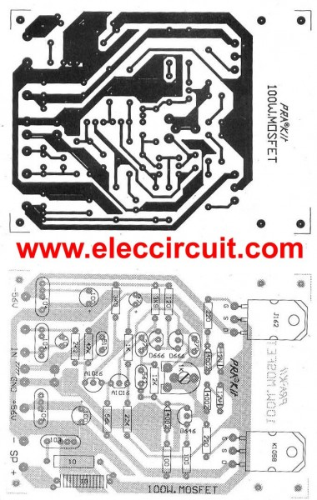](http://www.eleccircuit.com/wp-content/uploads/2012/09/The-pcb-of-100-watt-dc-servo-amplifier-by-power-mosfet.jpg)  
**The PCB of 100 watt DC servo amplifier by Power MOSFET**

- When sure that everything is ok then try to supply to this circuits. Without connecting the speakers. But using the a voltmeter to measure the voltage at the speaker. It need to be no the voltage or zero volts, if is not show that the, Circuits failure at any point exactly.

- And most important, it should not be overlooked is the soldering, especially, Beginners usually soldering is not good enough.  
- When pressure Have on center of R. Then, the next step is to adjust the Idle current for this circuit. Adjust only 35mA is enough.  
For installation into a metal box, just like a typical high watt amplifier circuits. What needs to be careful, is to install ground, Because If do not need to be will make Have simple oscillator.  
Remember, the ground of input and output circuit, should be on separate lines, and the ground at the same point for the PCB of this circuit, the input and output ground have separate neatly.  
- The ground wire, especially output and the power supply, use a large, durable power more than 15A.

The input enters this circuit, the point is that we can use two AC input and DC input depending on the requirements, but usually it is recommended AC Input is safer.  
**Source : pk kit circuit**

**If you like this project. Please buy here.**

**[1. Jameco Electronics : a leading electronic components distributor for over 35 years](http://www.avantlink.com/click.php?tt=cl&mi=10609&pw=72789&url=http%3A%2F%2Fwww.jameco.com%2Fwebapp%2Fwcs%2Fstores%2Fservlet%2FStoreCatalogDisplay%3FstoreId%3D10001%26catalogId%3D10001" \t "_blank)**